Princess of Wales Conservatory
Architectural tour notes by Gordon Wilson, architect of the conservatory

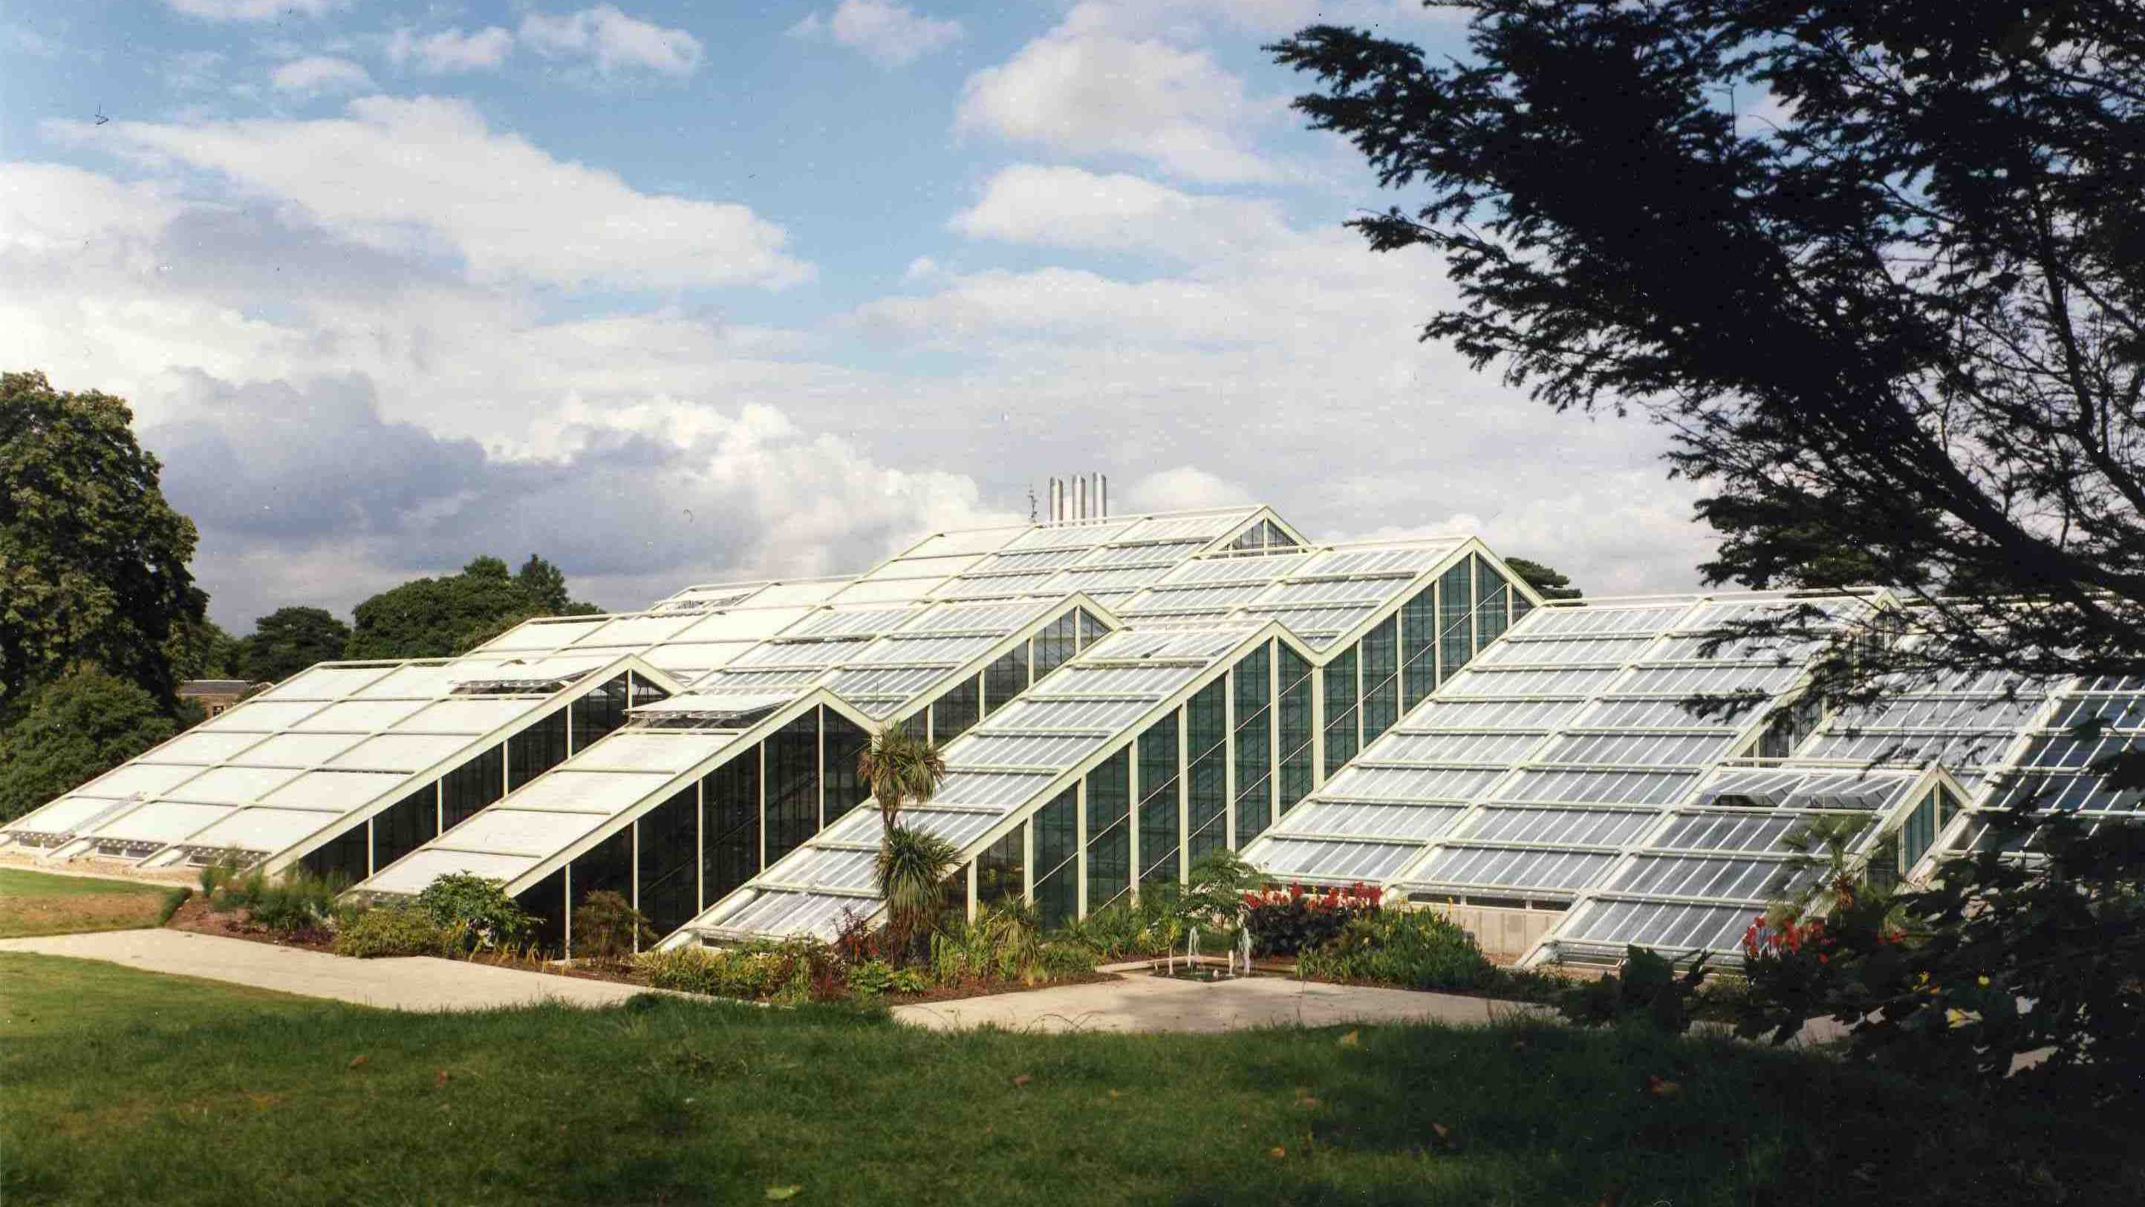
View of West side of the Princess of Wales Conservatory

An architectural tour of the conservatory is best started on the West side, from a point near the top of the ramp leading to the sunken courtyard area. This is a good location for explaining why the conservatory looks as it does externally, which will help in explaining the arrangements internally. Also, there is space for a group of people to gather and be given a brief introduction to the project

Part 1 of Tour - External

1. Background

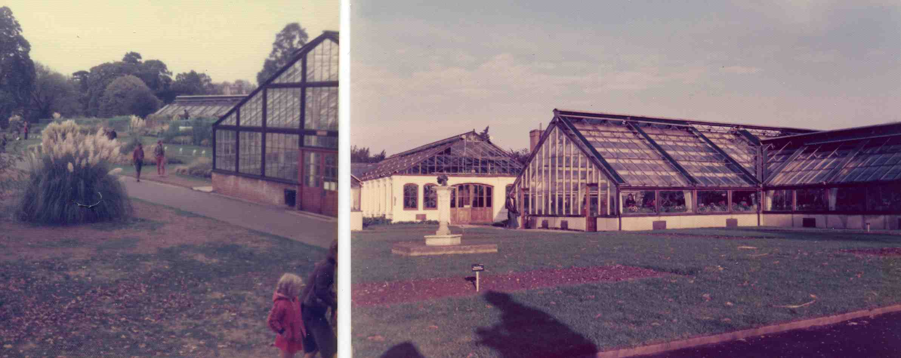
T-Range and Ferneries glasshouses previously existing on the site

The basic requirement was to replace fifteen old, energy-wasteful glasshouses, known as the T-Range and Ferneries, with a single structure containing 10 separate climatic zones totalling 4490sqm. This was to be Kew’s largest glasshouse in terms of ‘footprint’ and on a site that has historic importance close to the works of Burton, Chambers, Nash and Nesfield
The new conservatory was always going to be very different from the famous Palm House and Temperate House. Whereas those structures contained mostly tall trees within large single-volume spaces, this was to be a low structure to house Kew’s herbaceous plant collections having a maximum height requirement of approximately 7m for plants. Also, it was to be a multi-volume space, with the separate climatic zones having varying sizes and with optimum requirements for location together with some stringent environmental requirements. In addition, Kew required the building to have all the attributes of long life (a minimum of 100 years), ease of maintenance, public safety and improved energy conservation

Paragraphs 2 – 7 below describe the main factors influencing the design of every major conservatory

2. Basic Form

A conservatory’s general appearance normally evolves from a search for an optimum form to meet the natural lighting requirements that apply to most conservatories, i.e. the solar energy factor. In particular, light penetration in winter needs to be maximised so that imported plants can thrive without too much use of artificial lighting. Also, over-heating in summer needs to be minimised to reduce the cost of ventilation, shading or cooling

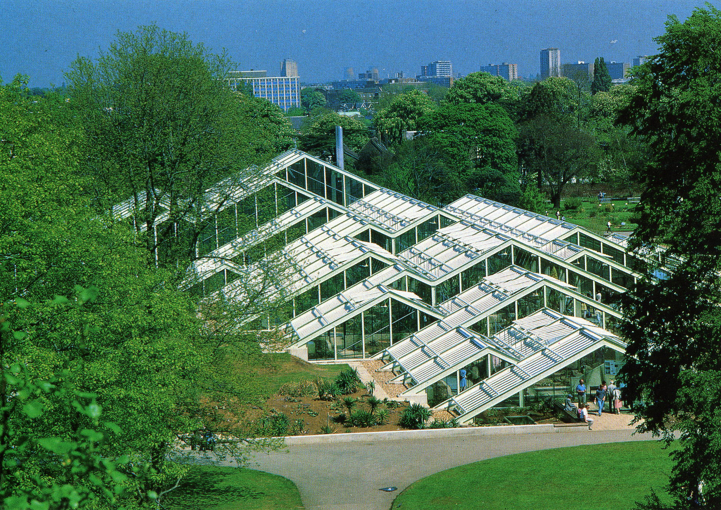
A sun-seeking, south-facing ‘hill’

- Assuming a standard configuration of glasshouse, with no need for external shading, a low winter sun penetrates best through a south-facing vertical glass wall and the effects of a high summer sun are reduced most by reflection off east and west-facing slopes. This is easily verified by considering the reverse configuration. Therefore, the basic building form has a ridge with a generally North-South axis, which also matches the axis of the site

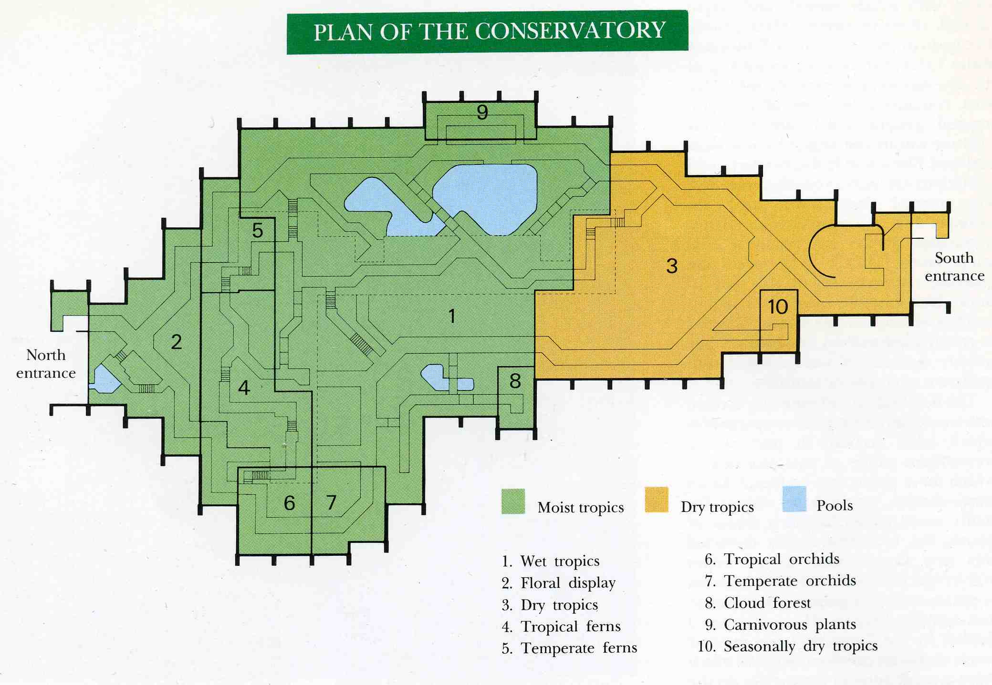

- This fundamental decision on building shape was developed to meet the requirements of the brief and site boundary constraints. The main zones have been arranged with the dry tropics at the South end, wet tropics in the centre and a temperate zone including a Winter Garden at the North end. The other zones have optimum locations around the perimeter to meet their special requirements

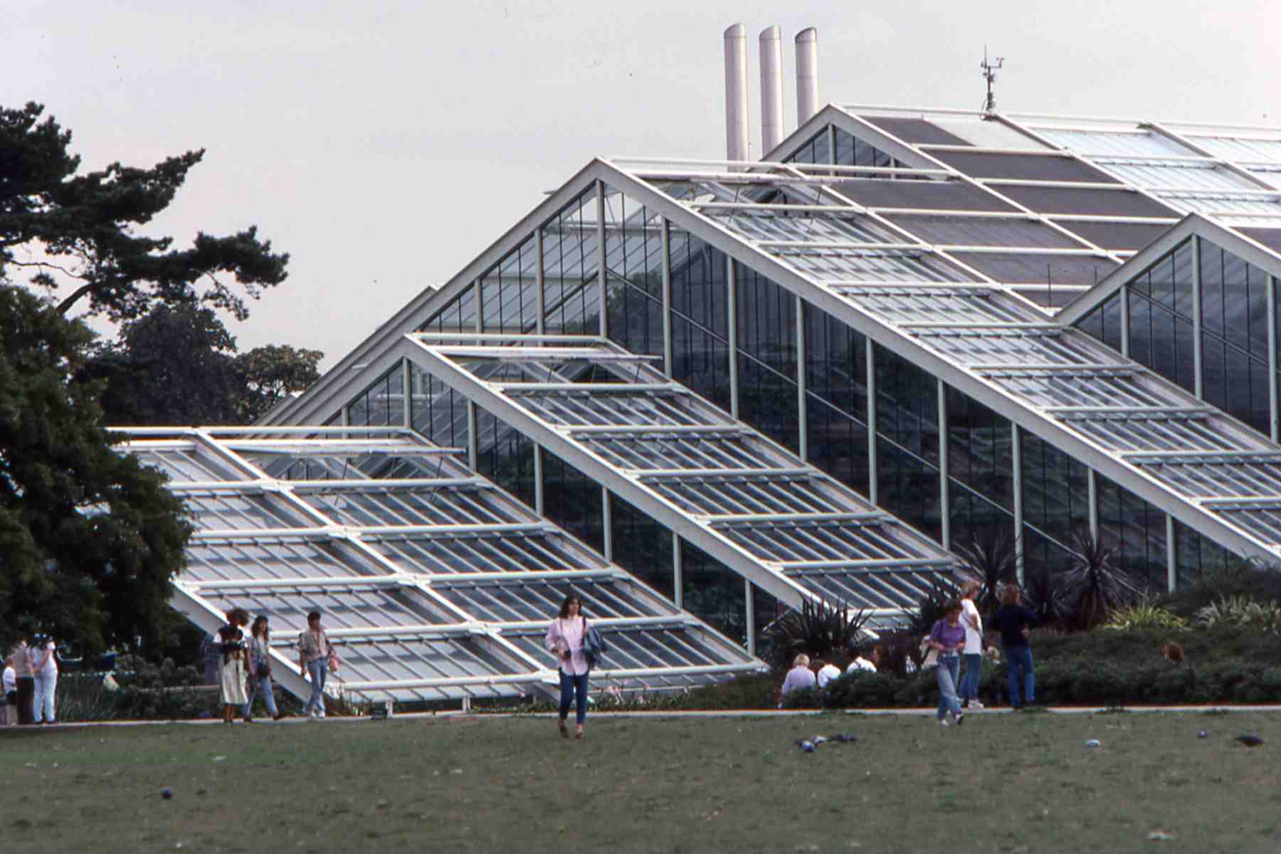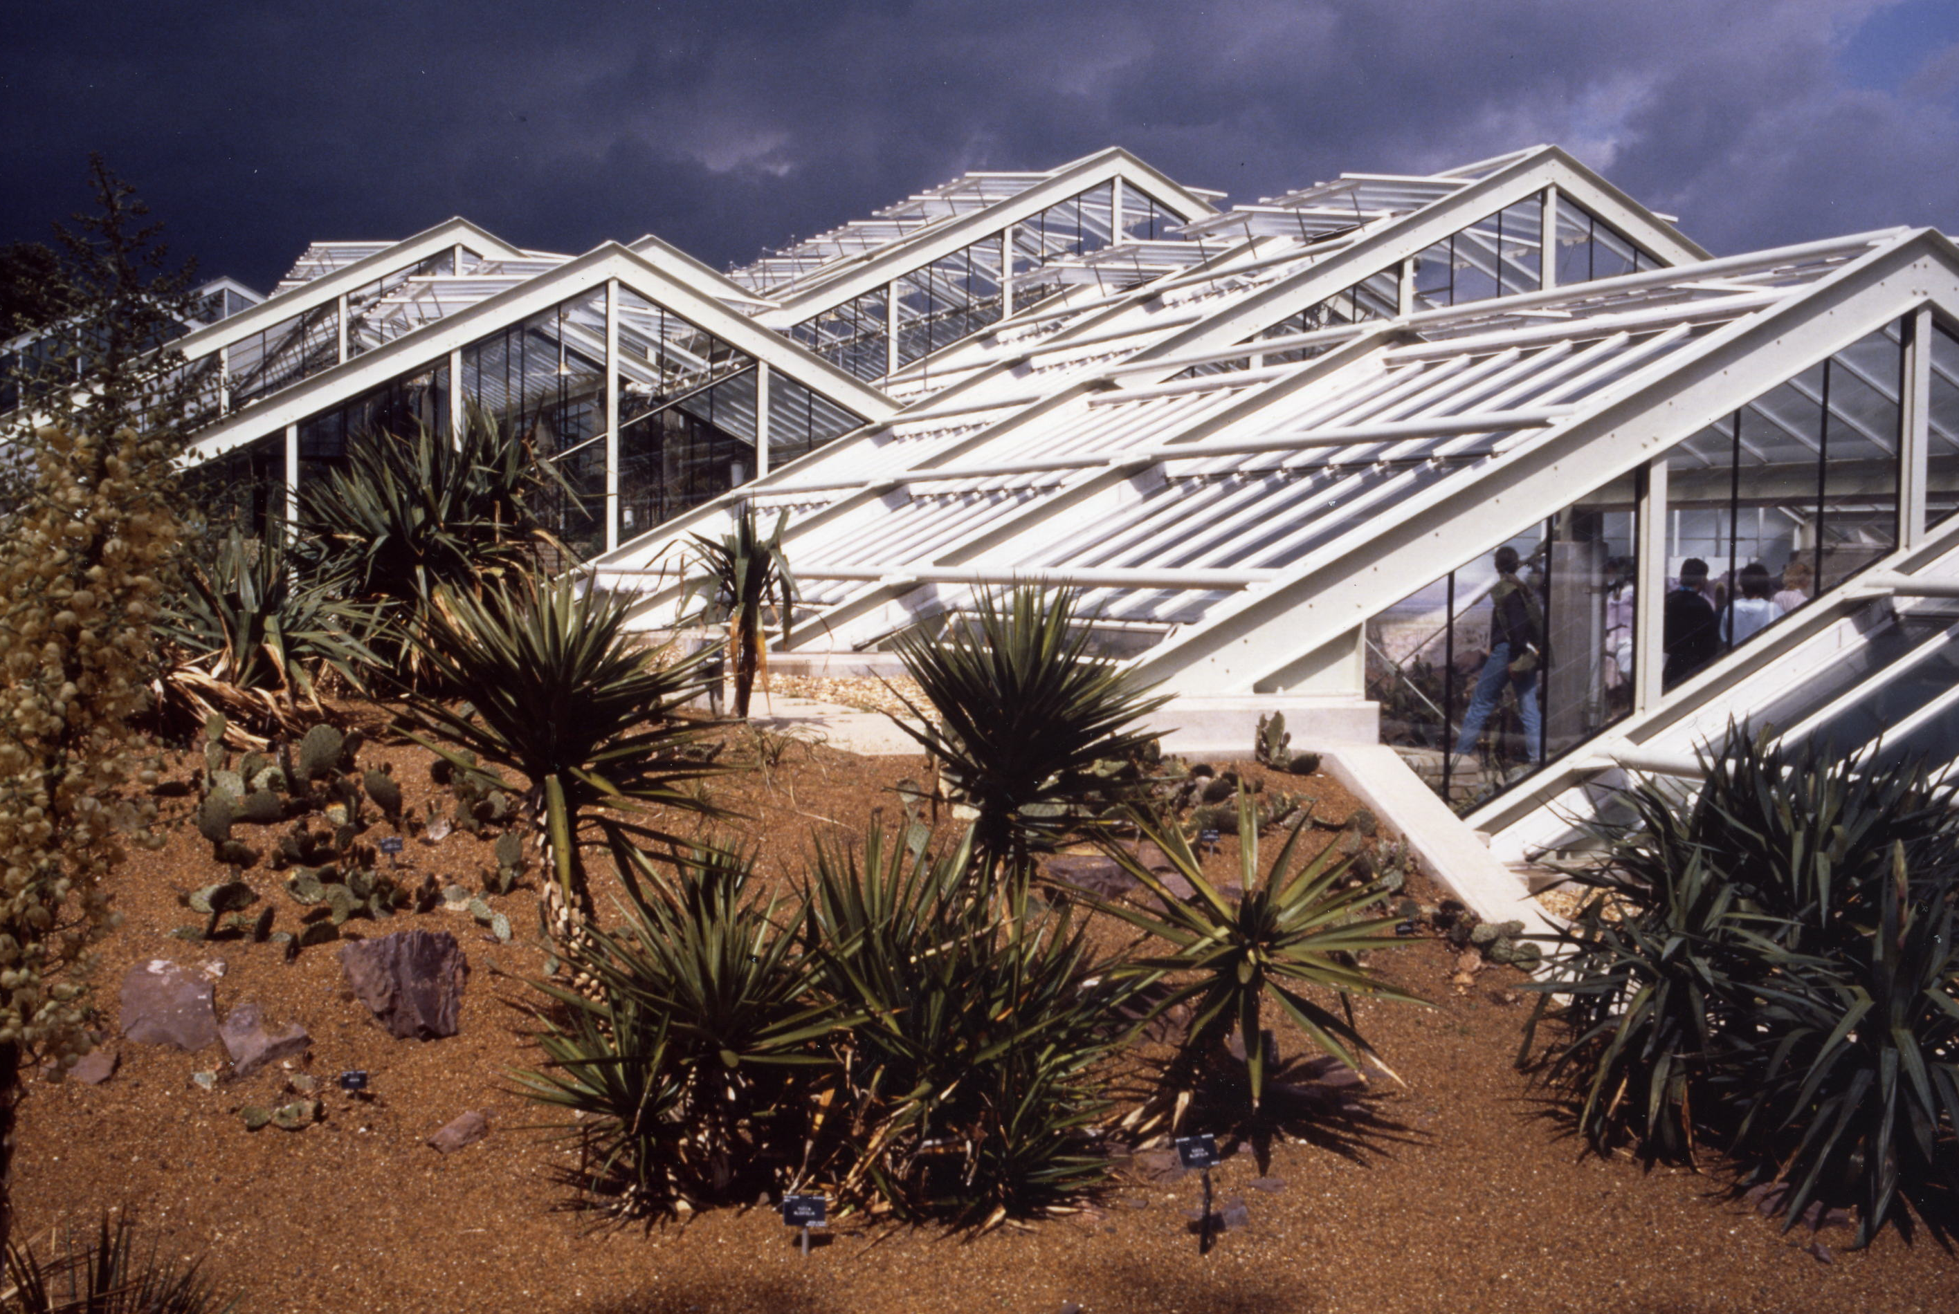
Traditional glasshouse roof-shapes Repetition of familiar forms

- In the basic building form, with its stepped and staggered shape, there is recognition that traditional glasshouse roof-shapes have traditional virtues – easier condensation control, fewer cleaning problems and simpler maintenance access. Where the building plan needed to be wider, the basic roof shapes are simply repeated and joined by valley gutters. Familiar forms are thus put together in a new way, reflecting new requirements, knowledge and attitudes

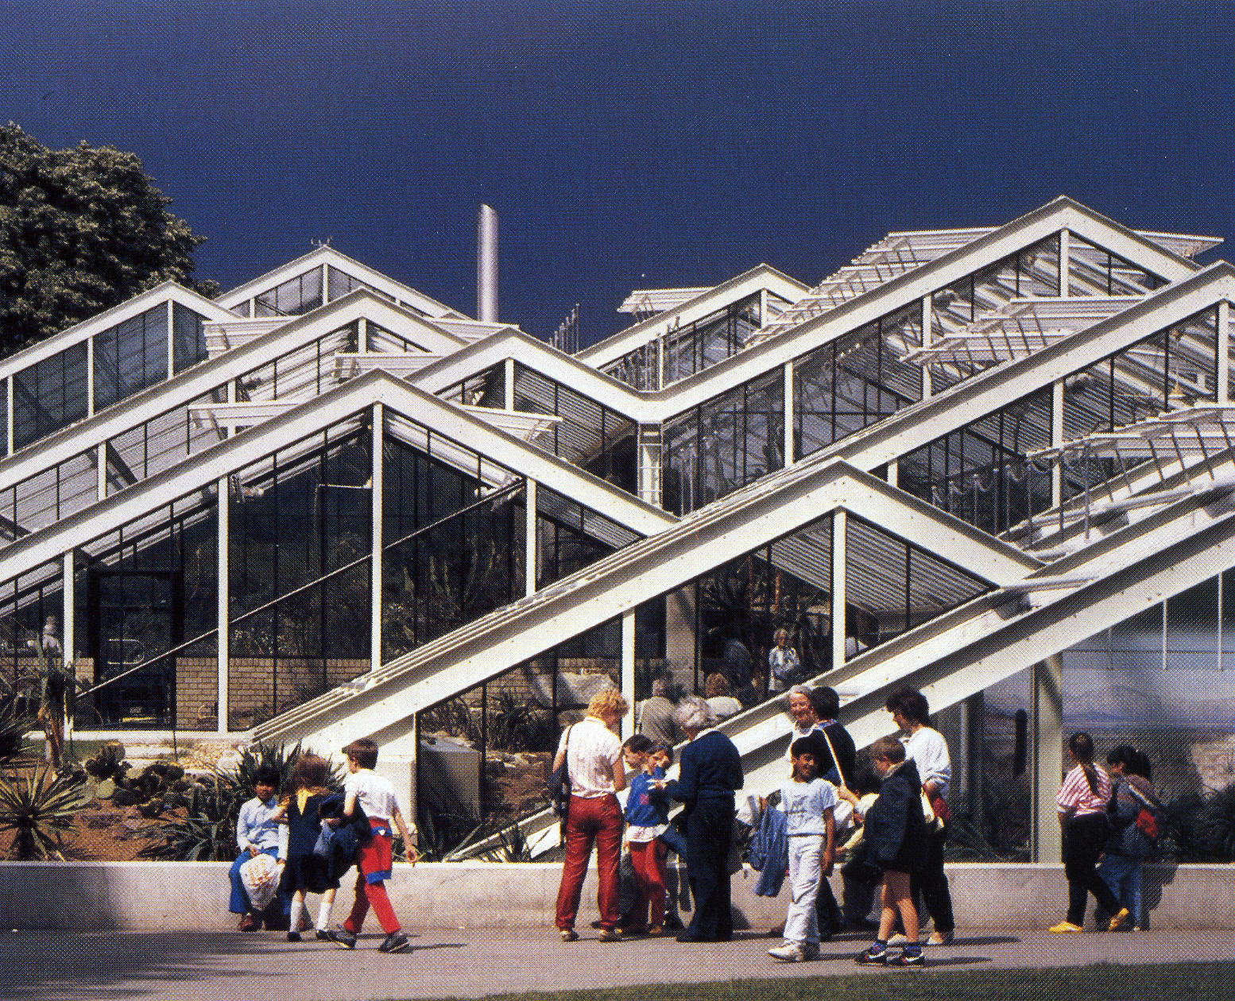
Cascade of roof forms ends at the southern entrance

- The building appearance can be described as a sun-seeking, south-facing ‘hill’, with low valleys contrasting with prominent ridges to help create a satisfactory dynamic. As a visitor moves around the building, the rhythm of the forms changes. This creates a dynamic, contemporary form can be compared to the more static forms of the 19-th century glasshouses nearby

- Such an explanation can help to counter questions such as – “why does the new conservatory not have curved forms?” or “why cannot the new conservatory be more like the Palm House?” If a questioner persists, a satisfactory response is to agree that curved forms can look good, but they also create problems for maintaining the building and for shedding rain-water. In addition, a building with a curved roof presents a face perpendicular to the light entering, which is good for improving winter light levels but not for resisting summer overheating

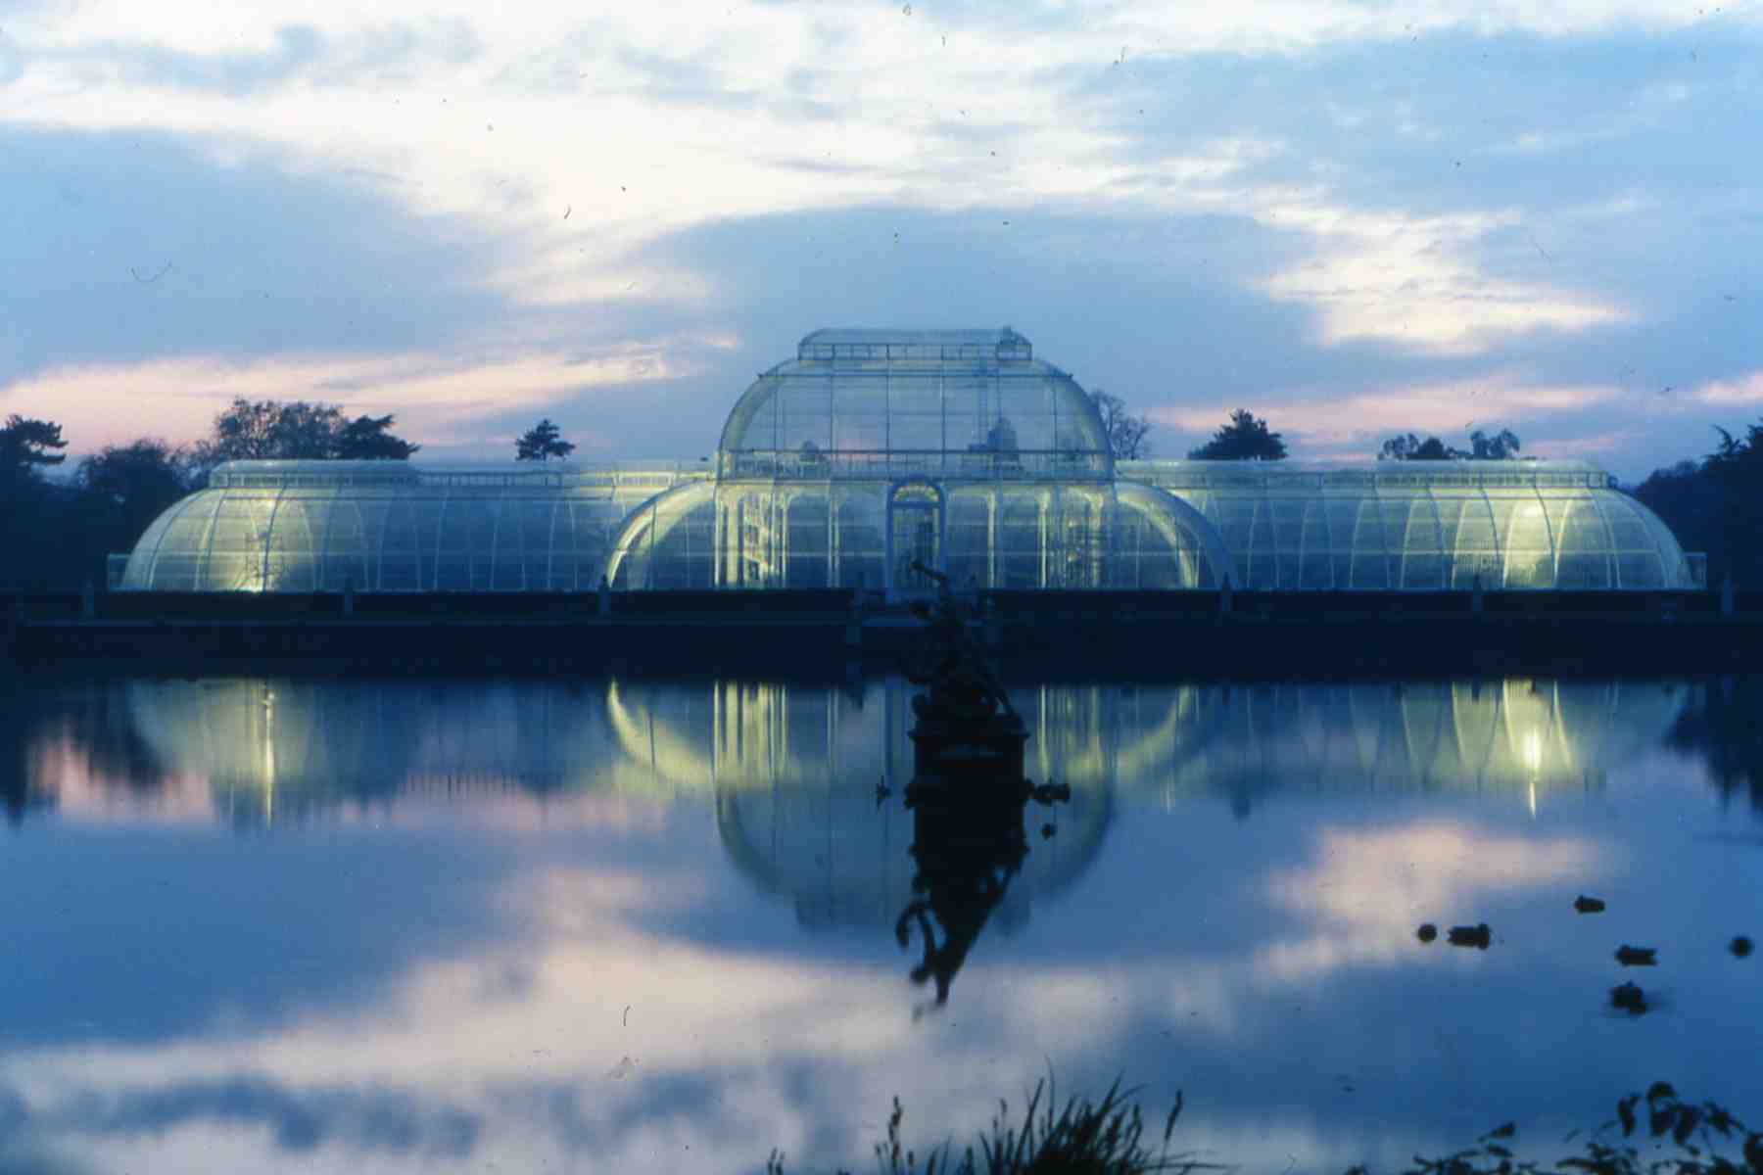
Curvilinear elegance of the Palm House

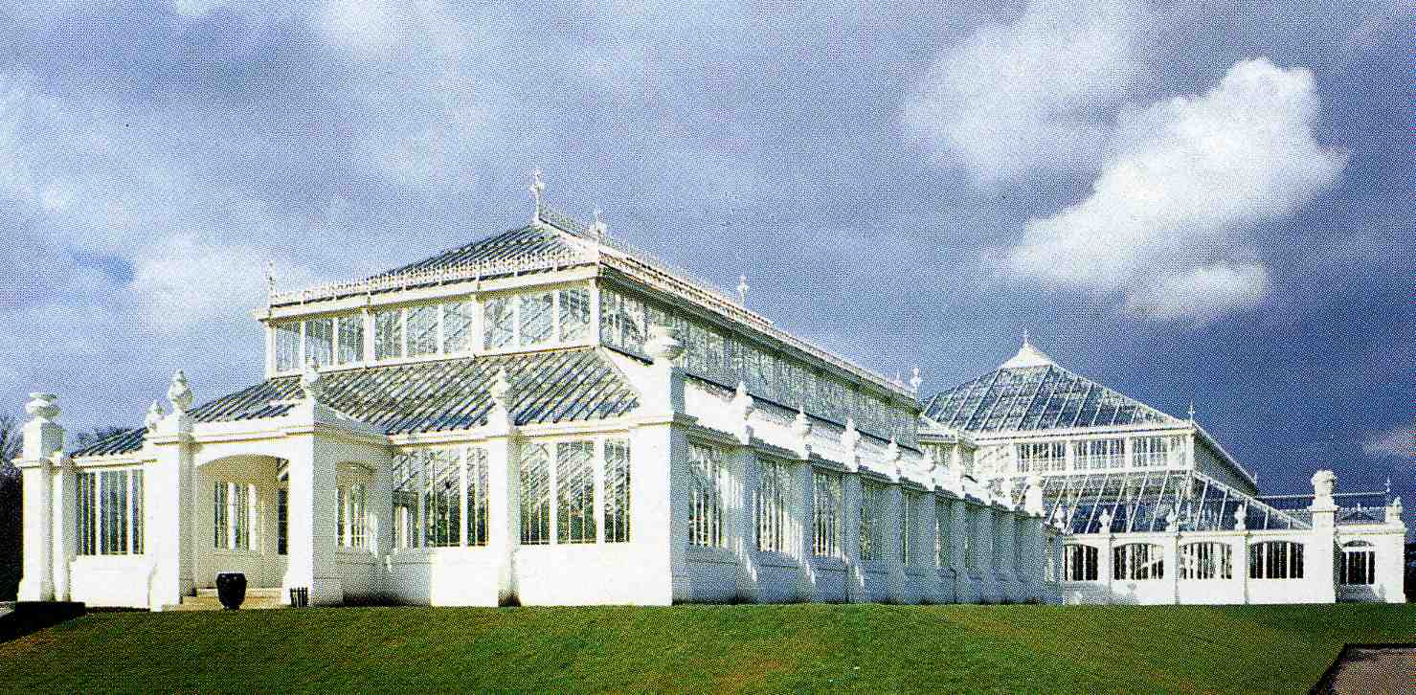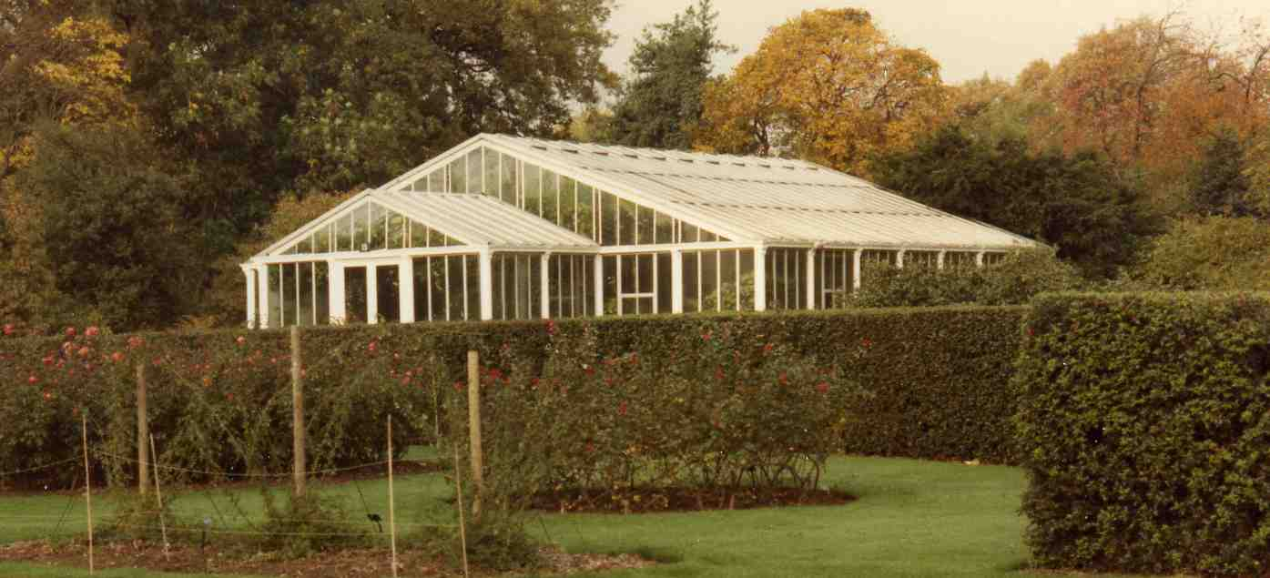
More traditional Temperate House Water Lily House

- The curvilinear Palm House is a magnificent response to the challenges of its special brief, the site potential and the knowledge and attitudes of the time. When the Temperate House and Water-Lily House were designed a few years later however, there was a return to the more traditional straight-roof forms. A conservatory’s orientation and form are the key issues for a successful design and the search for an appropriate, optimum form should be rigorous

3. Setting

All conservatories can be considered as sculptural objects in the landscape. However, only designs that are also fully integrated with their surroundings will have a satisfactory sense of ‘place’

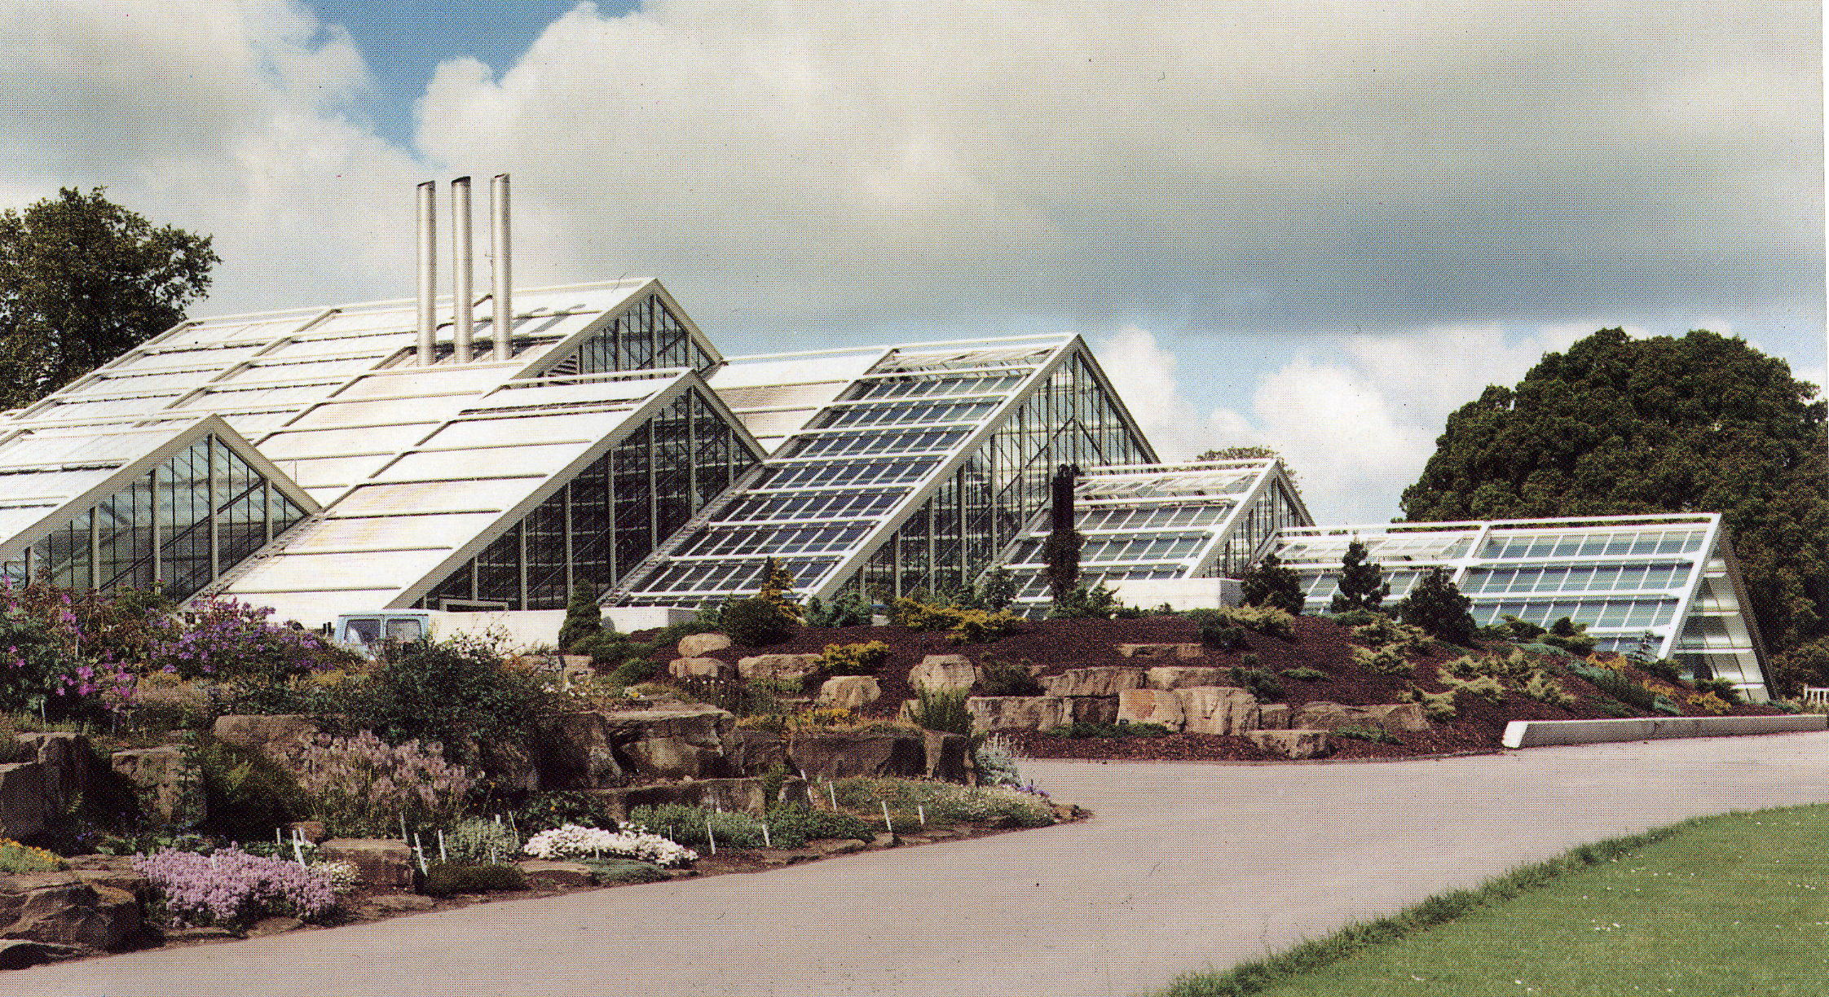
Ground levels on the perimeter blend into a historic landscape

- A building of this size in such a sensitive setting, including the Rock Garden to the East and the Ice House to the West, had to be designed with respect for context. Here, there has been a conscious attempt to integrate the building with the landscape. The roof planes are expressed as a cascade of forms, from a maximum height of 11.4m down to various ground levels

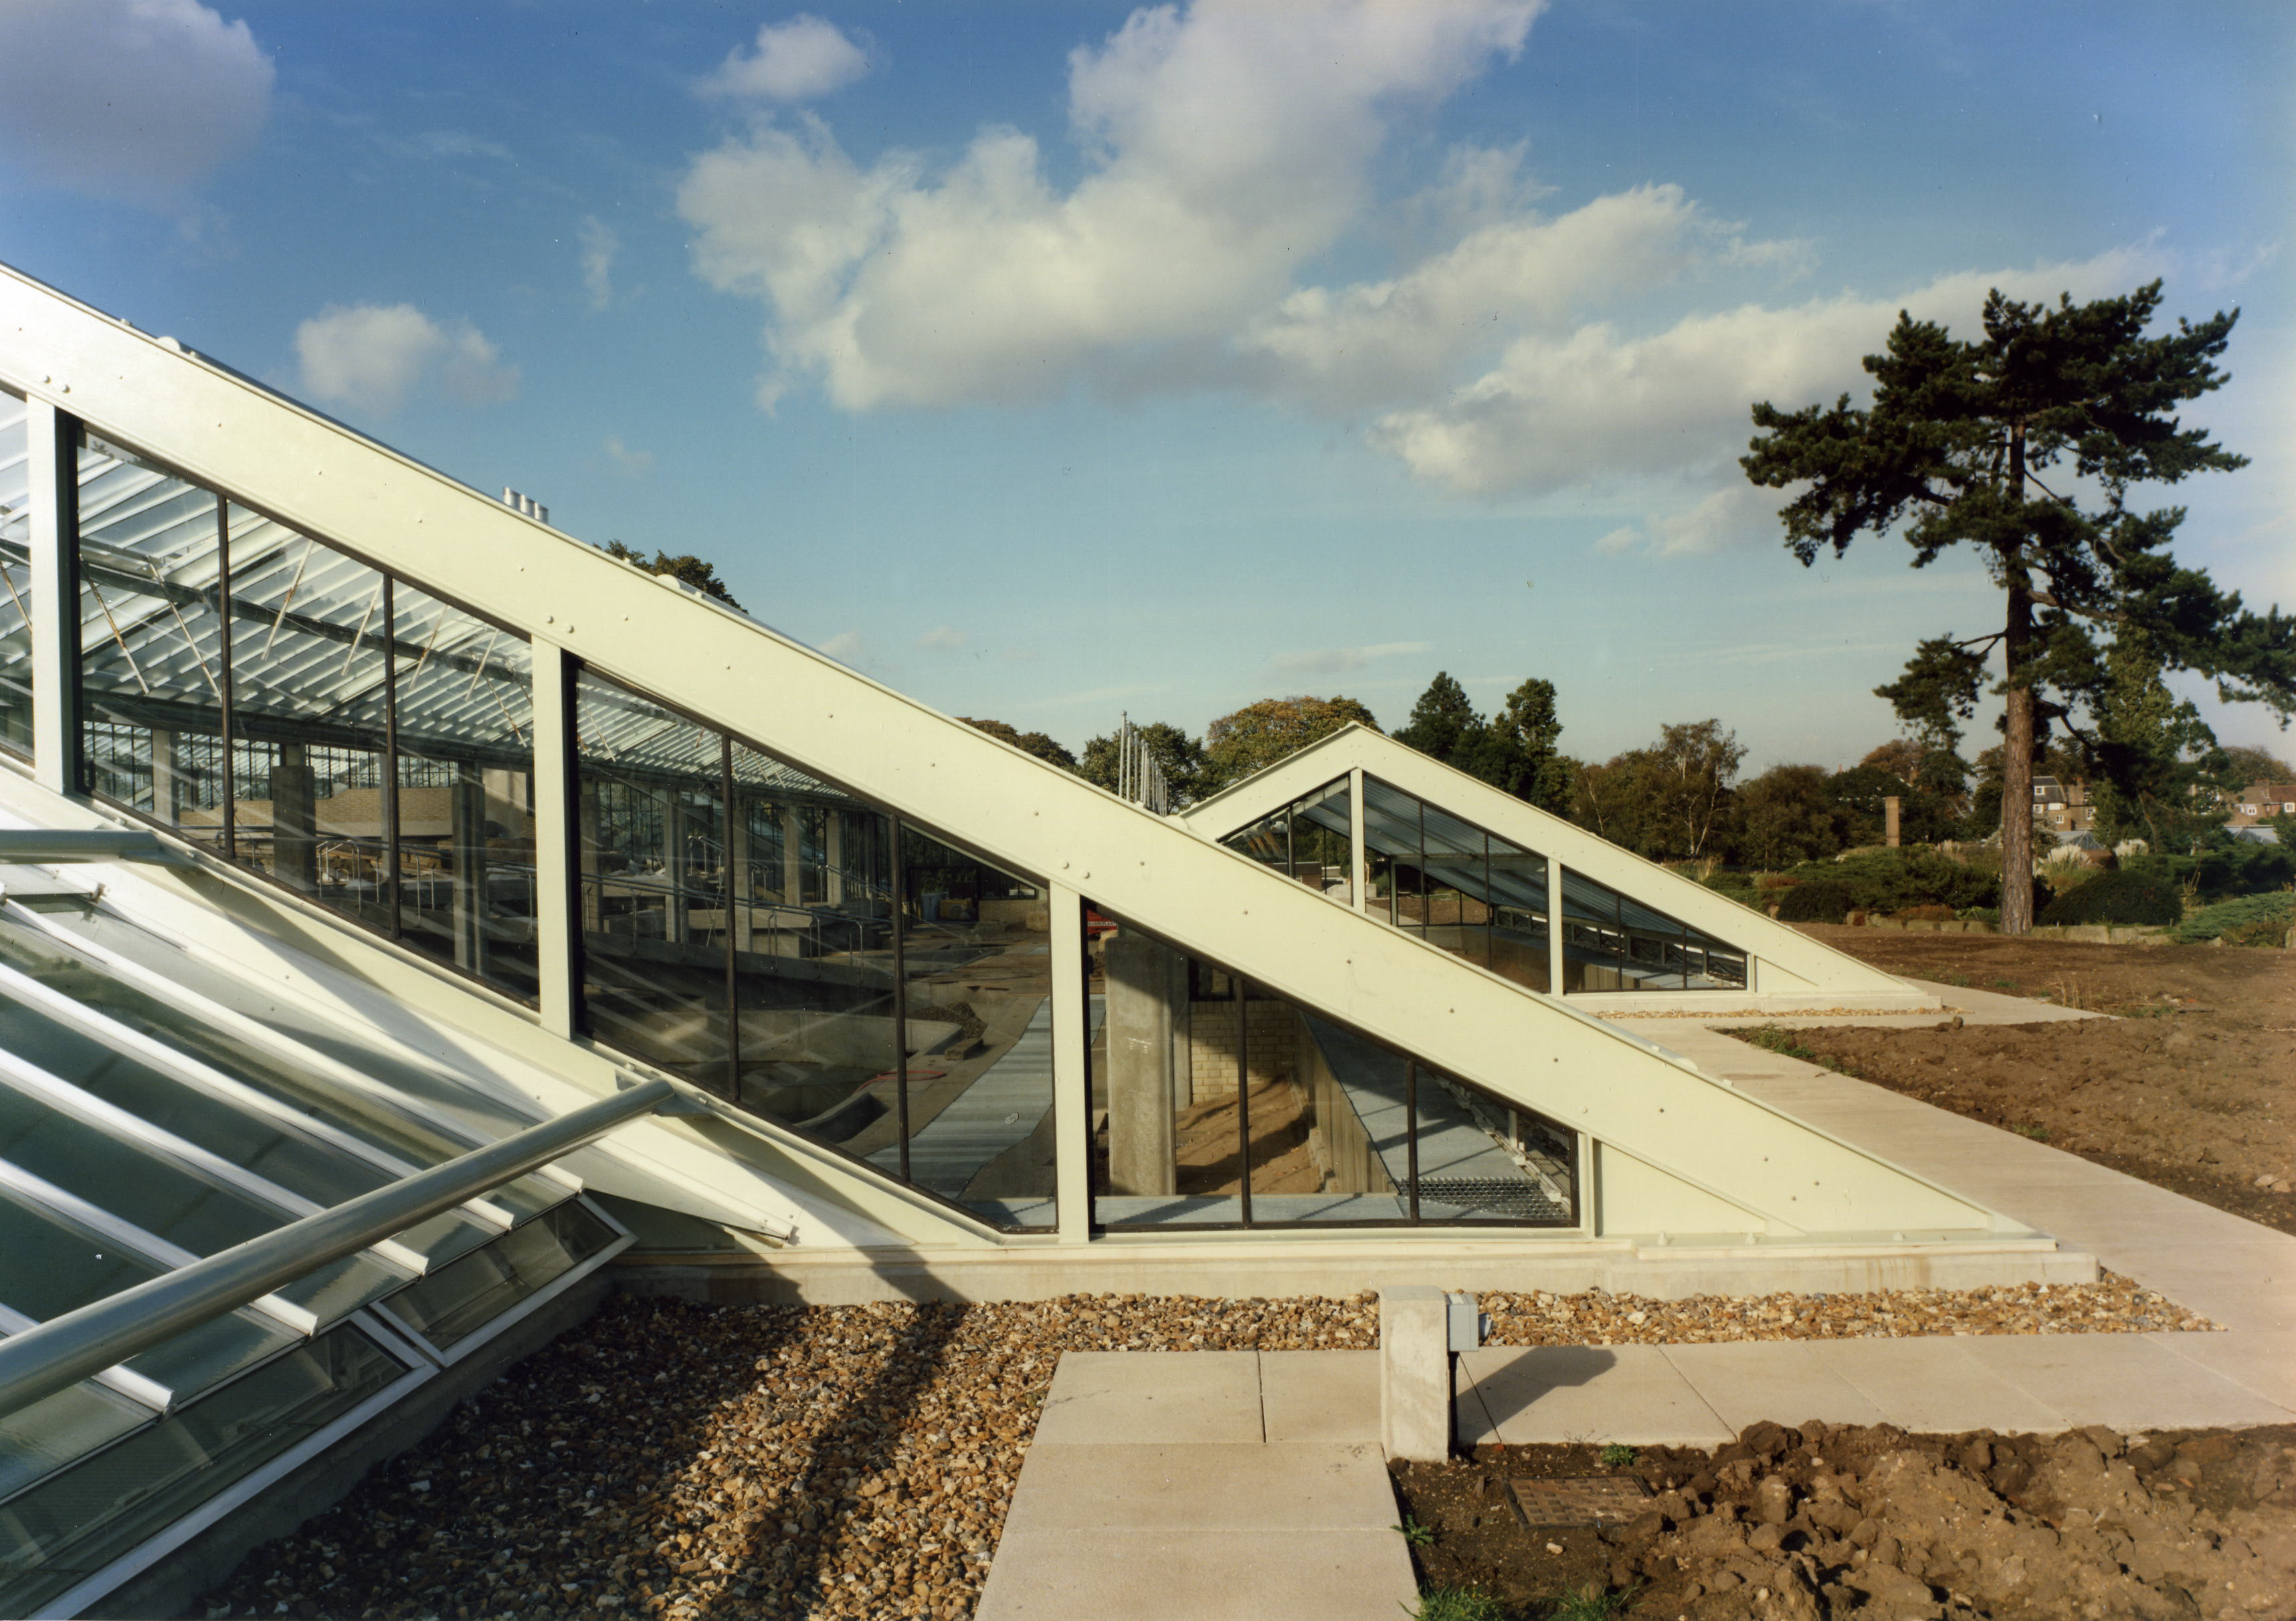
Typical junction of East/West roof plane with raised ground level

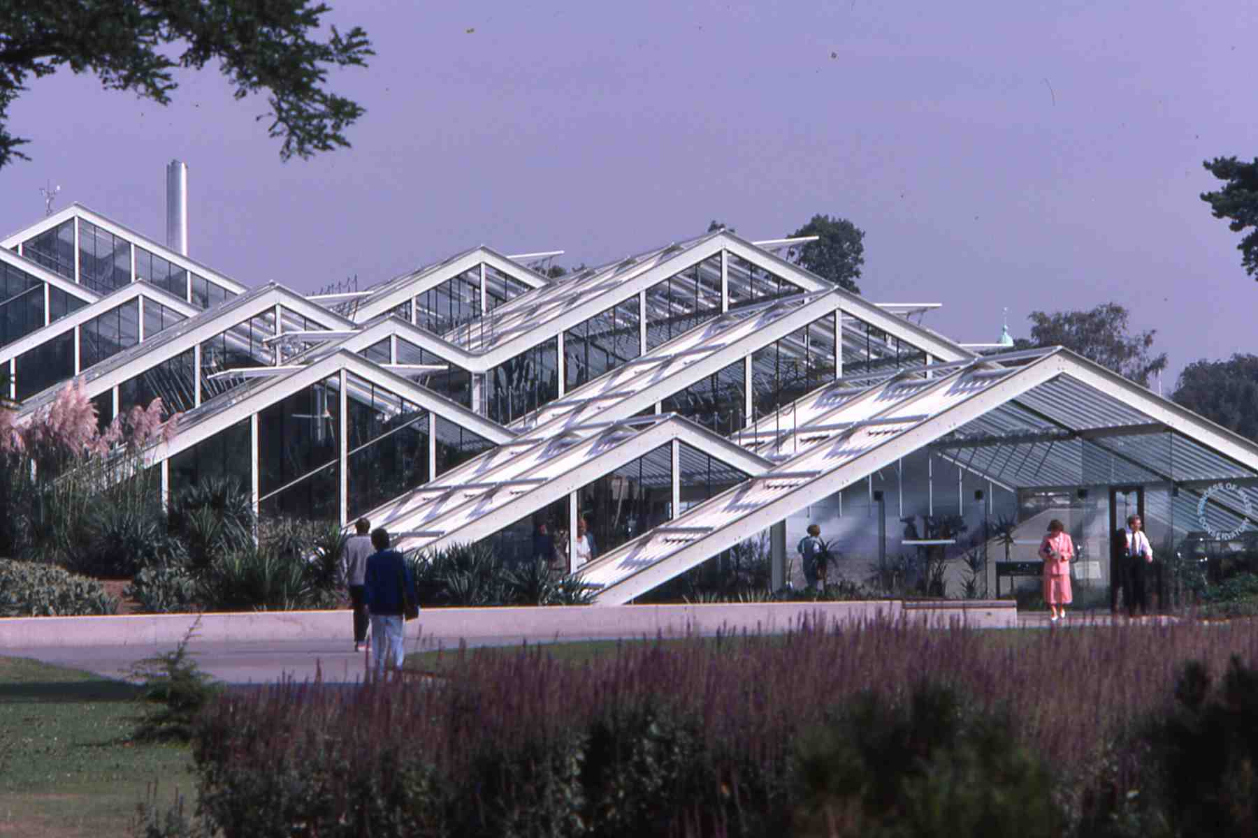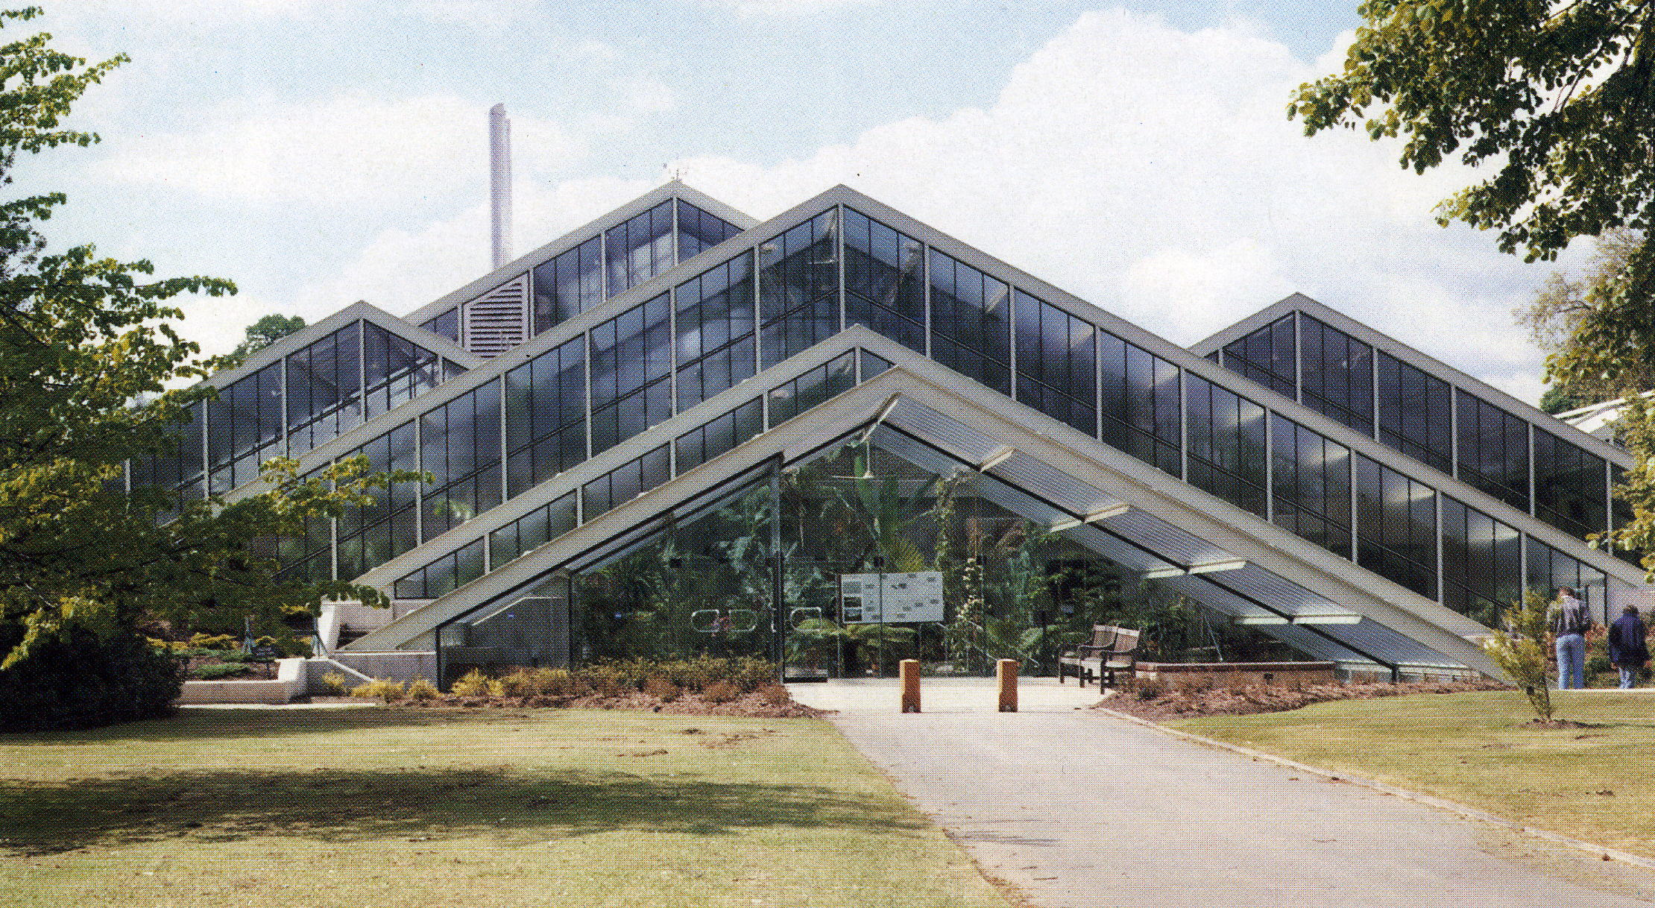
Roof planes at South entrance and at North entrance

- On the East and West sides the building’s side walls are hidden and the ground levels are raised to create a neat junction with the sloping roof planes. On the vertical South-facing glazing, the ground levels are lowered in places to permit more light to enter. At both the South and North entrances, the roof planes return to the existing ground level to acknowledge the importance of the site and the building’s special affinity with nature

In this way, new and existing ground levels are blended to help create a cohesive relationship between the new conservatory and historic elements of the landscape

4. Structure

A conservatory structure cannot be hidden. The issue is how best to express it. This will depend on the relationship between the structure and its glazed skin. This is normally either supported above an internal structure or suspended below an external structure and there are some examples of the glazing being fixed to a structure which is part-internal and part-external. The best relationship depends on the requirements for the interior space. The simpler the space and the higher the roof, the easier it will be to accommodate an internally-expressed structure. The more complex the space and the lower the roof, the more important it will be for the structure not to dominate the plants

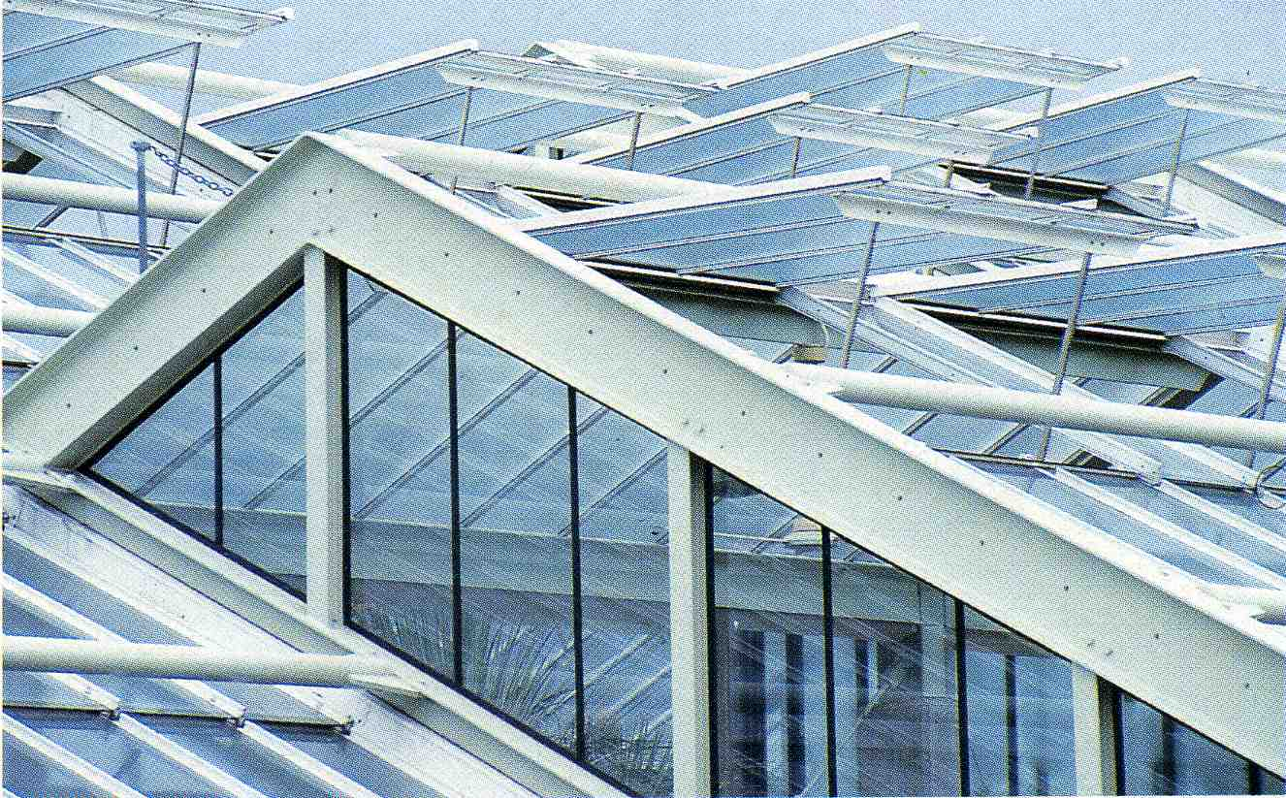
Expression of structure is mainly external and only partly internal

- The philosophy for expressing the structure of the new conservatory was simple. The needs for successfully growing, displaying and viewing these herbaceous plant collections under a low roof were paramount. Therefore, the structure seen from inside was played down so as not to dominate the planting, whilst the structure seen from outside was allowed too express itself. In addition, a part-internal and part-external structure was the simplest way to achieve both a stepped and staggered building form

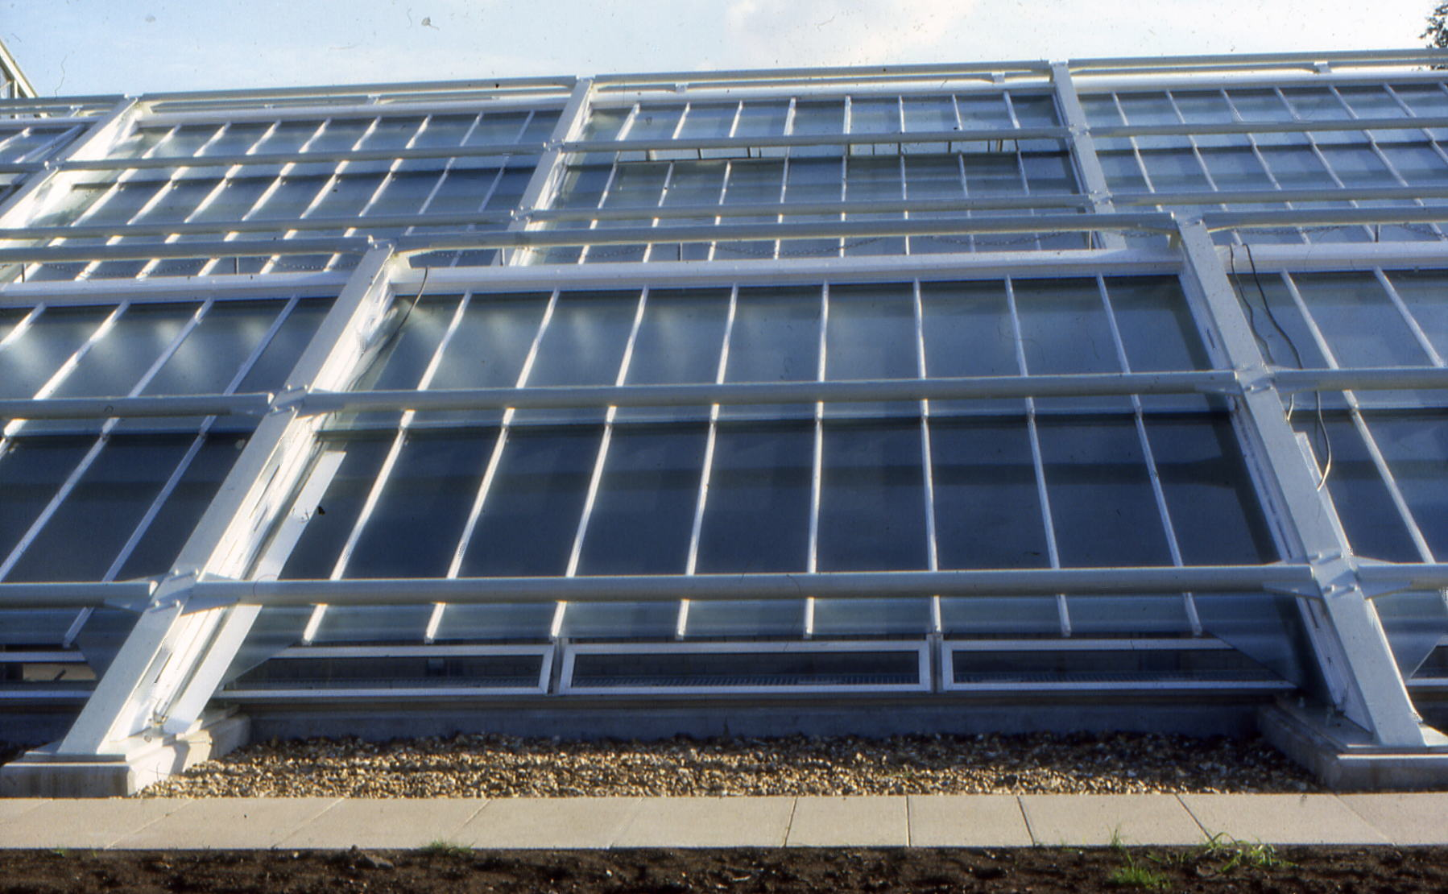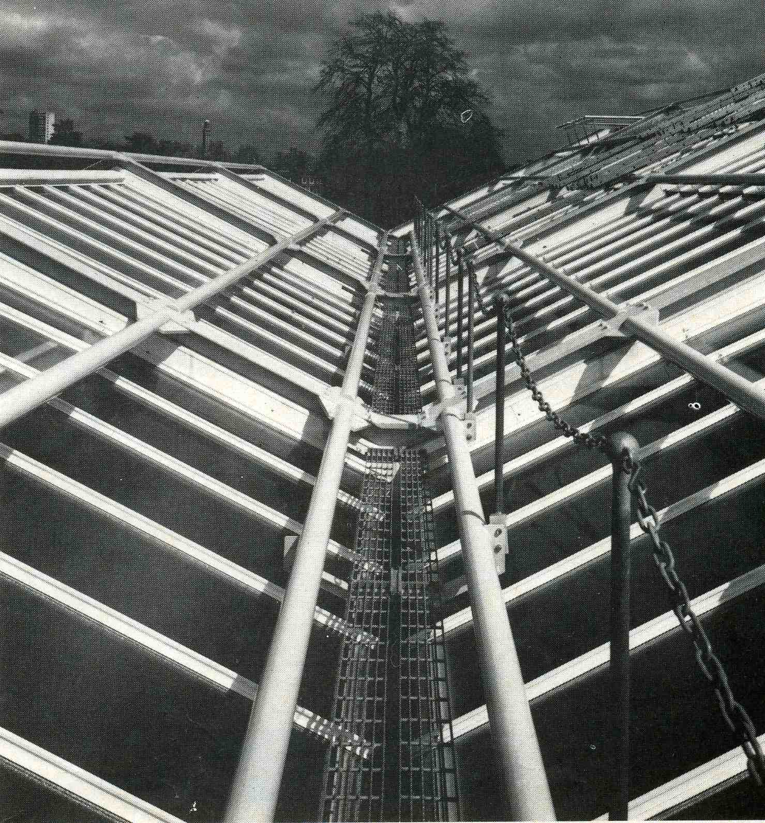
Tubular struts also support maintenance ladders Valley gutter walkway

- The mild-steel tubular struts, fixed to the top flanges of the beams, not only resolve the longitudinal, Vierendeel forces in the roof plane but also double up as the external, maintenance access supports. They support a removable, light-weight ladder system and the permanent, valley gutter walkways. In addition, they help to articulate the building form and give a satisfactory sense of scale

5. Glazing

The glazed skin is the largest, most important element of any conservatory. It has to meet a number of highly specialised requirements for detailed design – isolating the external environment, condensation control, maximising light values to benefit plants, providing a calm, non-distracting background for viewing plants, permitting an unobtrusive routeing of services and a simple and safe maintenance regime with easy access both above and below the roof. Working under a glazed roof can be difficult in a conservatory with tall, valuable plants. Failure to resolve this satisfactorily is a common criticism of many conservatory designs. A related issue is that of safety, not just for the staff required to clamber over or under a glazed roof, but for the public - especially if glass rather than plastic is used in the glazing

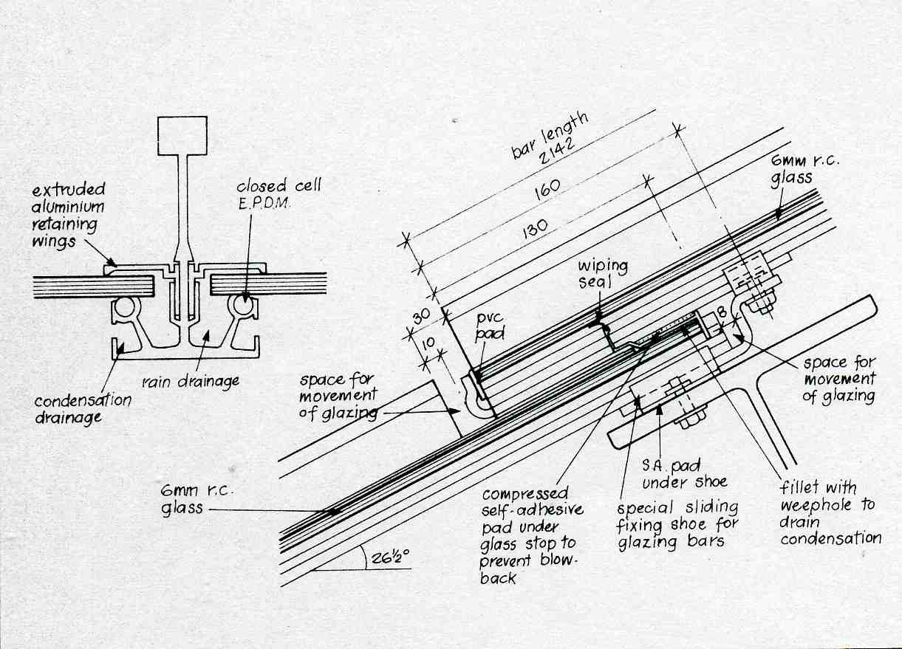
Glazing overlap detail

- Plastic glazing was considered, but not chosen, for the new conservatory, mainly because the technology of the time could not guarantee the same long life associated with glass. Here, the roof glazing comprises single panes of 6mm rough-cast glass, with a special detail at the overlap to control condensation without building up algae as well as to seal against air loss

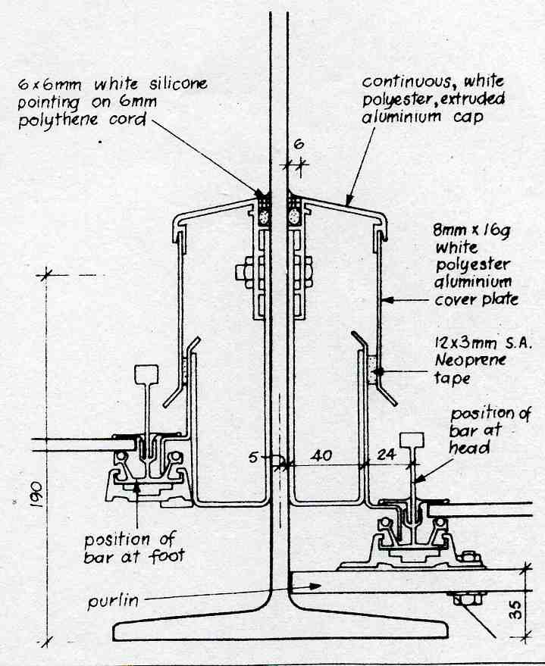
Electrical distribution duct

- The aluminium flashings alongside each roof beam also serve as local cable ducts for internal, roof-mounted equipment. A main distribution duct runs outside the building perimeter, under a pathway, with cable entry ducts cast through each concrete buttress. Maintenance under the glazed roof relies mainly on the use of a demountable staging system supporting a working platform up to a height of 10m. Other systems, including a roof gantry or using a ‘cherry-picker’, were considered but were not appropriate for the whole building. It is essential that all parts of a conservatory roof can be accessed. Public safety was ensured by selecting a patent glazing system capable of holding, firmly in place, any panes of cracked, un-toughened glass

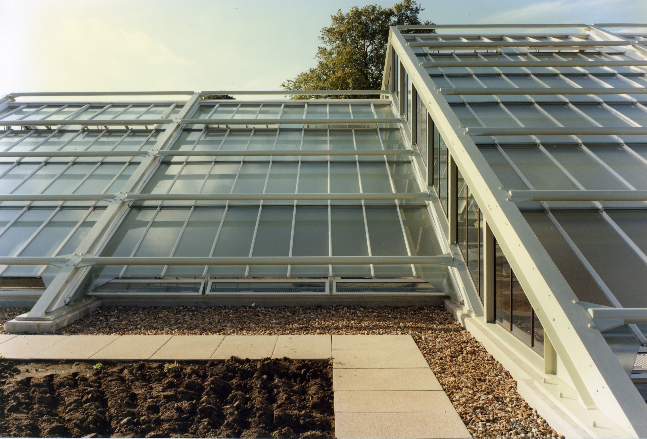
Vertical clear glazing against textured glass in sloping roof

- Rough-cast glass was chosen for the aluminium patent glazing in the sloping roof for several reasons. Seen externally, it helps to maximise the expression of external structure. Seen internally, the texture helps to hide the external structure and allow the planting to dominate (more shortly). Also, its use in conjunction with the clear glass gables helps to express the roof planes.

6. Energy

The needs for energy conservation should have a significant influence on the design of any new conservatory. There is no single, easy way to save energy. Rather there is a range of incremental responses to the many aspects of the subject. All the natural energy sources are involved and the aim is to avoid waste. Apart from making optimum use of solar energy in the building form, there is also the need to conserve precious soil, air and water

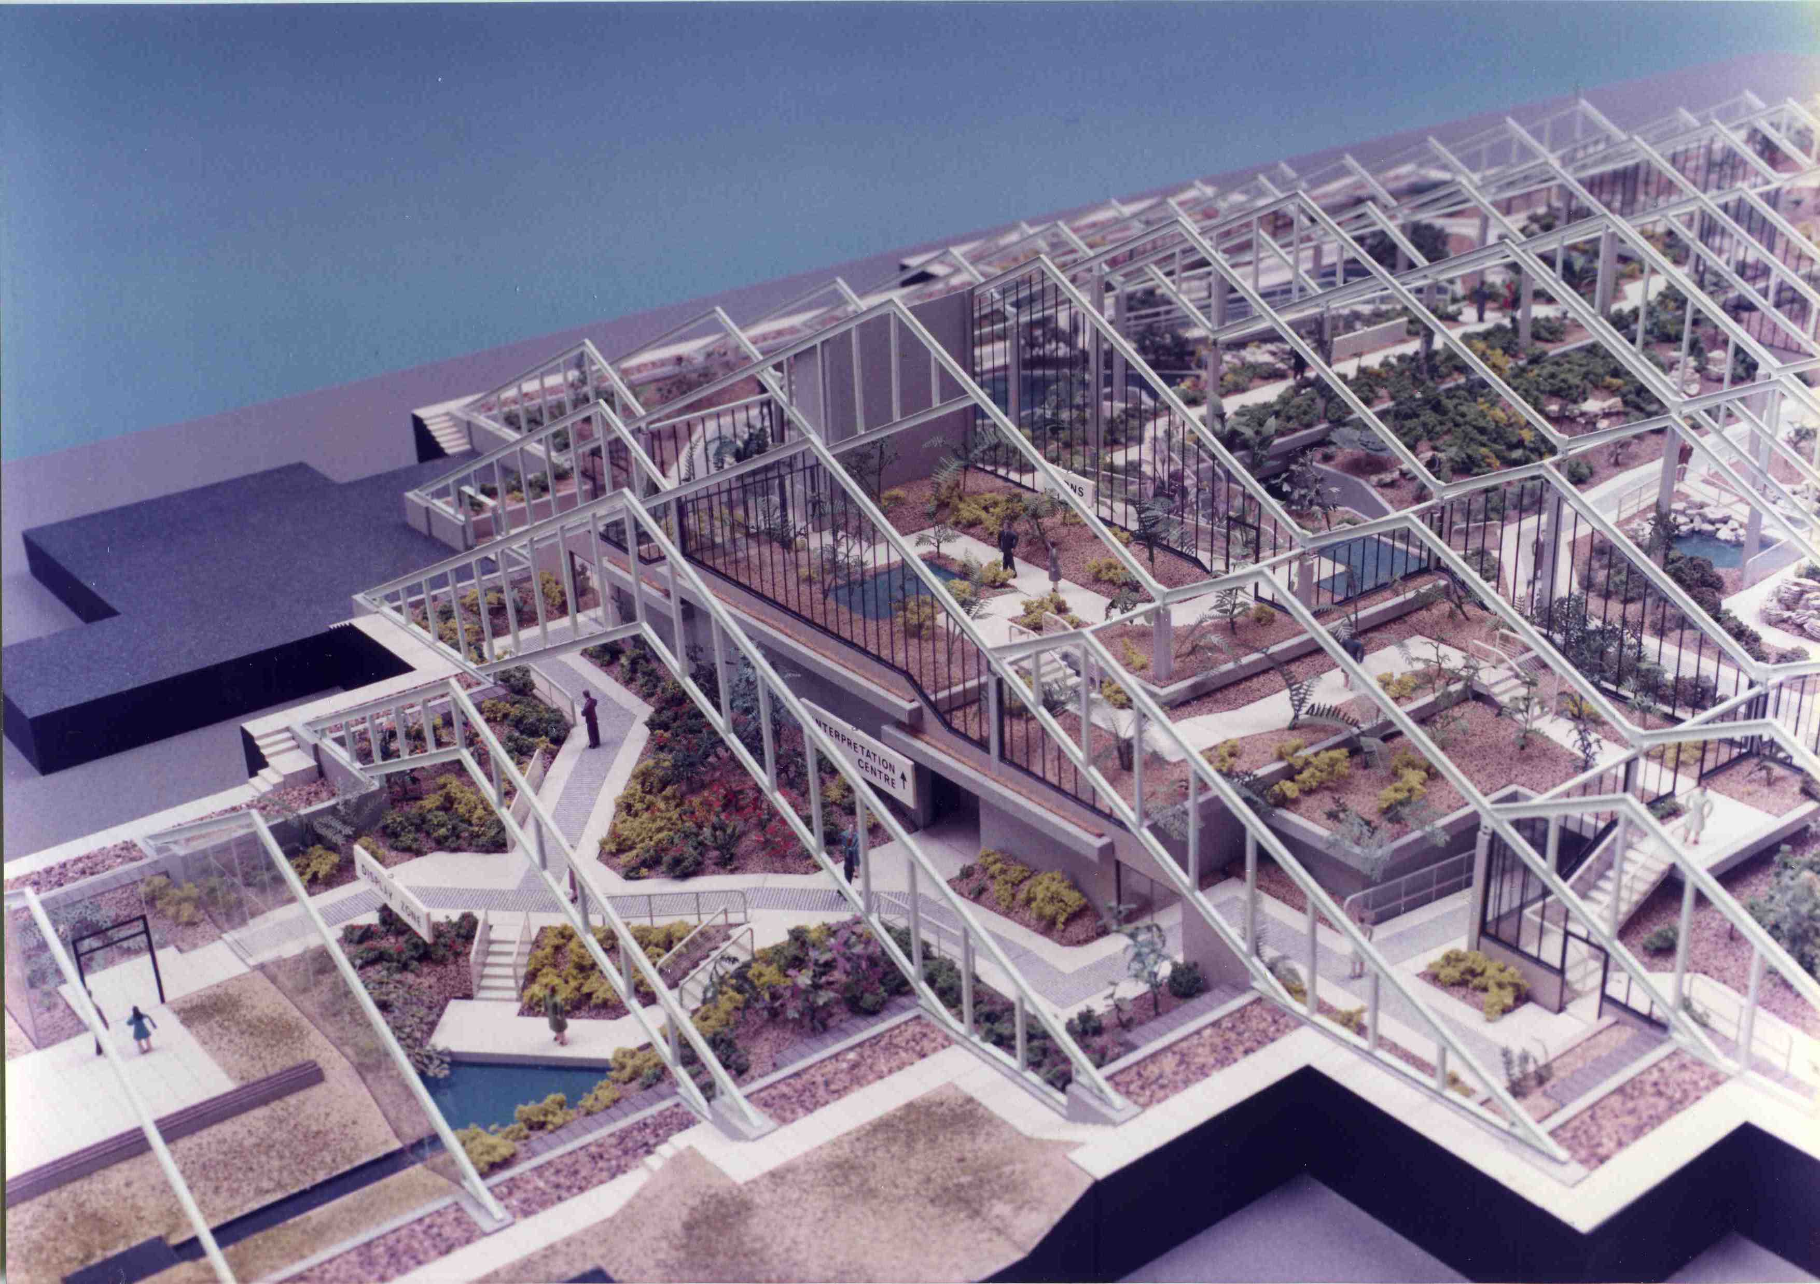
Pre-construction model showing the northern end of the planted-over central service area

- The plan arrangement has the warmer, more humid climatic zones towards the centre, approached through the cooler planting zones at the North and South entrances. Also, the building is designed as a solar collector storing heat in its concrete sub-structure, including the concrete deck over the central service area. This raised planting effectively reduces the height and volume further in an already relatively low volume space. In addition, more heating fuel is saved by insulating the side walls with earth banks, having the glazing overlaps in the roof sealed and the public entrances lobbied

- Externally, rain-water is collected off the roof, stored in underground tanks and treated before being used on the plants. Internally, the design and management of the displays have been influenced by savings in other natural energy sources (more shortly)

7. Cost

Conservatory costs can vary significantly according to needs. Two particular factors can be highlighted. The first is that a standard, commercial glasshouse designed to last, say, 25 years may be a quarter the cost of a glasshouse designed to last over 100 years. The second is that a large-span structure can escalate in cost in geometric proportion to the span. For a given floor are, a large-span structure can easily cost 3 or 4 times as much as a small-span structure. The structural span philosophy is therefore one of the most critical cost factors to be considered

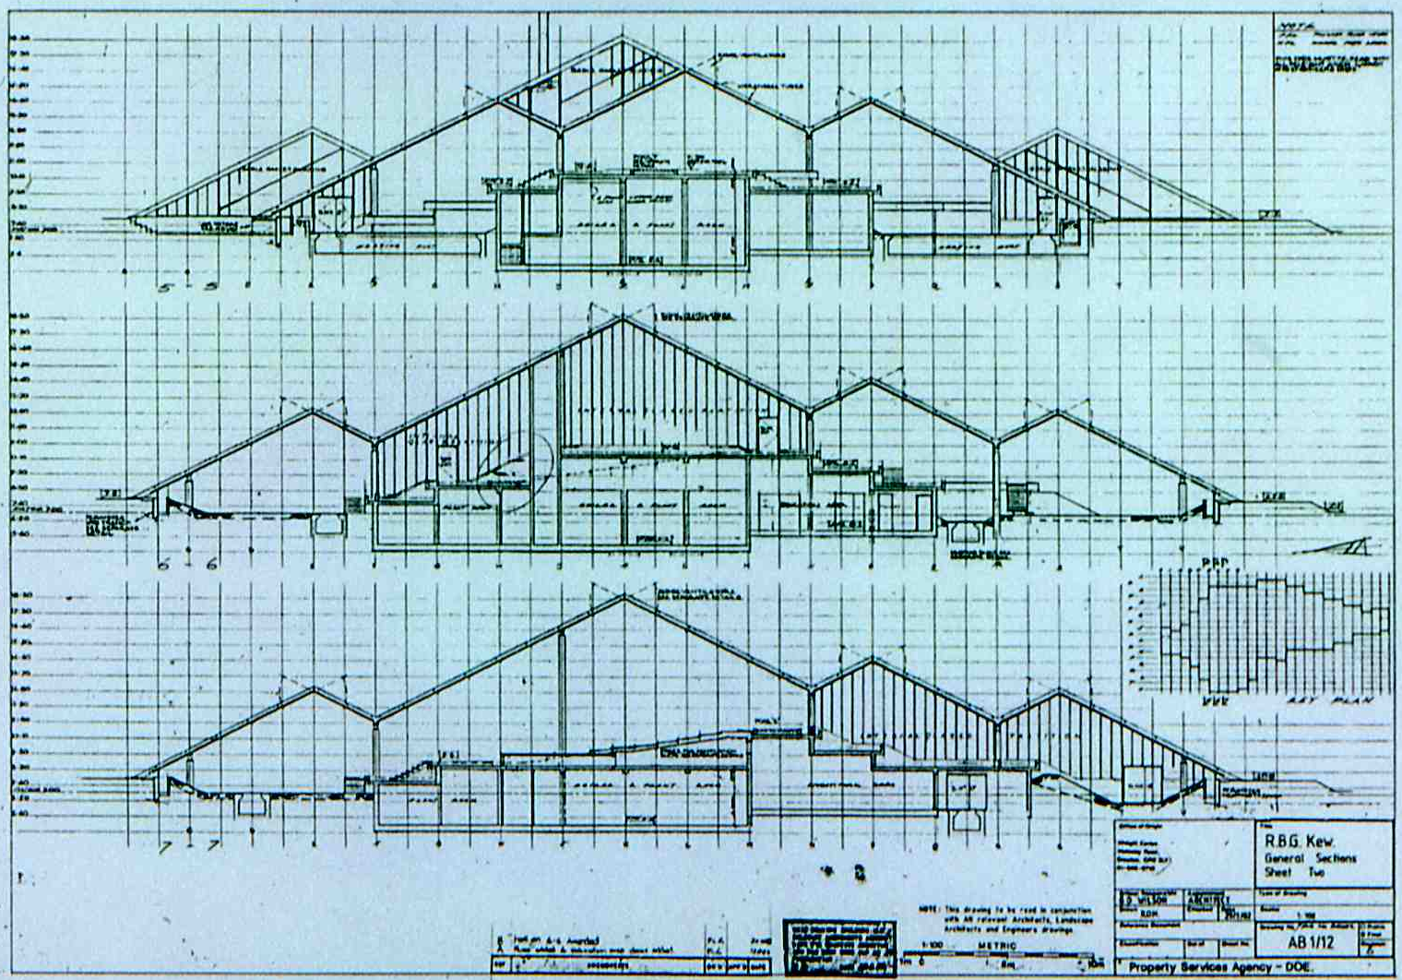
Typical sections illustrate the low-roof, small-span philosophy

- Here, the building has many internal columns and the small-span approach resulted in a largest internal span of 14.4m. Columns are considered to be helpful for displaying plants and to be positive, non-intrusive elements in the internal landscape

The final construction cost on completion in 1985 was approximately £5M for an area of 4,400sqm, i.e. a cost of approximately £1100/sqm. This compares favourably with the cost of other major conservatories seen at that time. Some major conservatories in N. America and Europe cost double or triple this figure

Part 2 of Tour – Internal

More detailed design factors, in paragraphs 8-21 below, can be considered as the tour proceeds internally

8. South entrance and transition zone

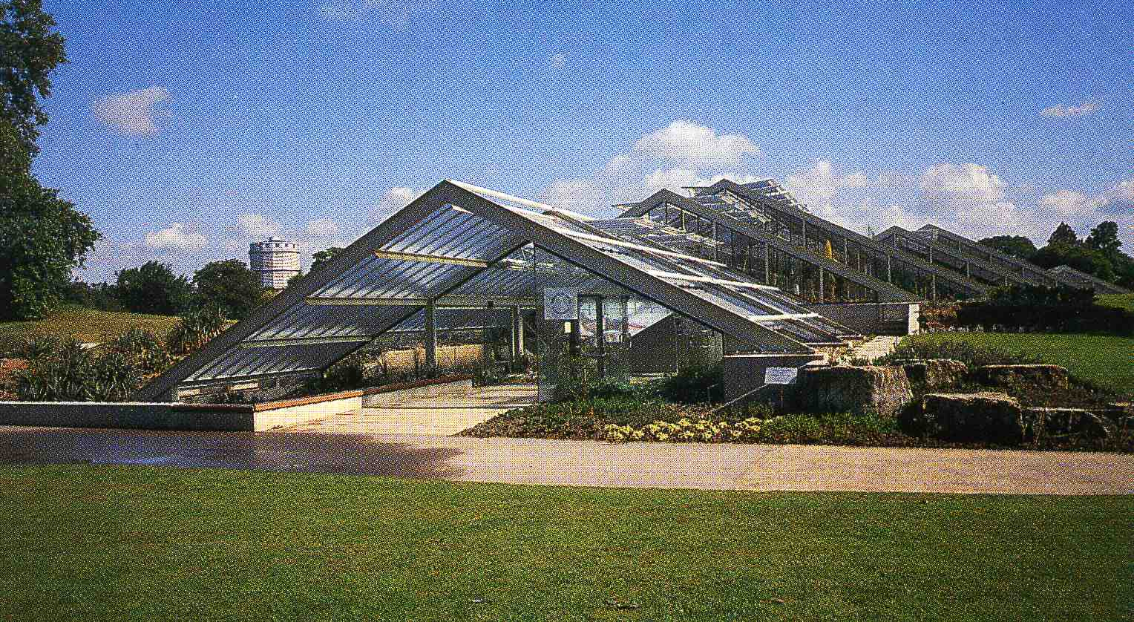
South entrance with clear glass walls and landscape features
At both North and South entrances, the wide, roof canopy sweeps down to ground level to acknowledge the site and to draw in visitors from different directions. Standing back from the South entrance, at a point where the roof can be viewed from both above and below, visitors can assess how the rough-cast glass, fixed low in the beams, helps to maximise the external expression of structure seen from above and to minimise the internal expression of structure seen from below. Under the canopy, the clear glass walls help to provide a strong visual link between exterior and interior. Ornamental water is an important element in the overall design and, here, water movement provides animation and sparkle. Together with the planting and paving, it helps to ease the transition for visitors

9. Introductory spaces

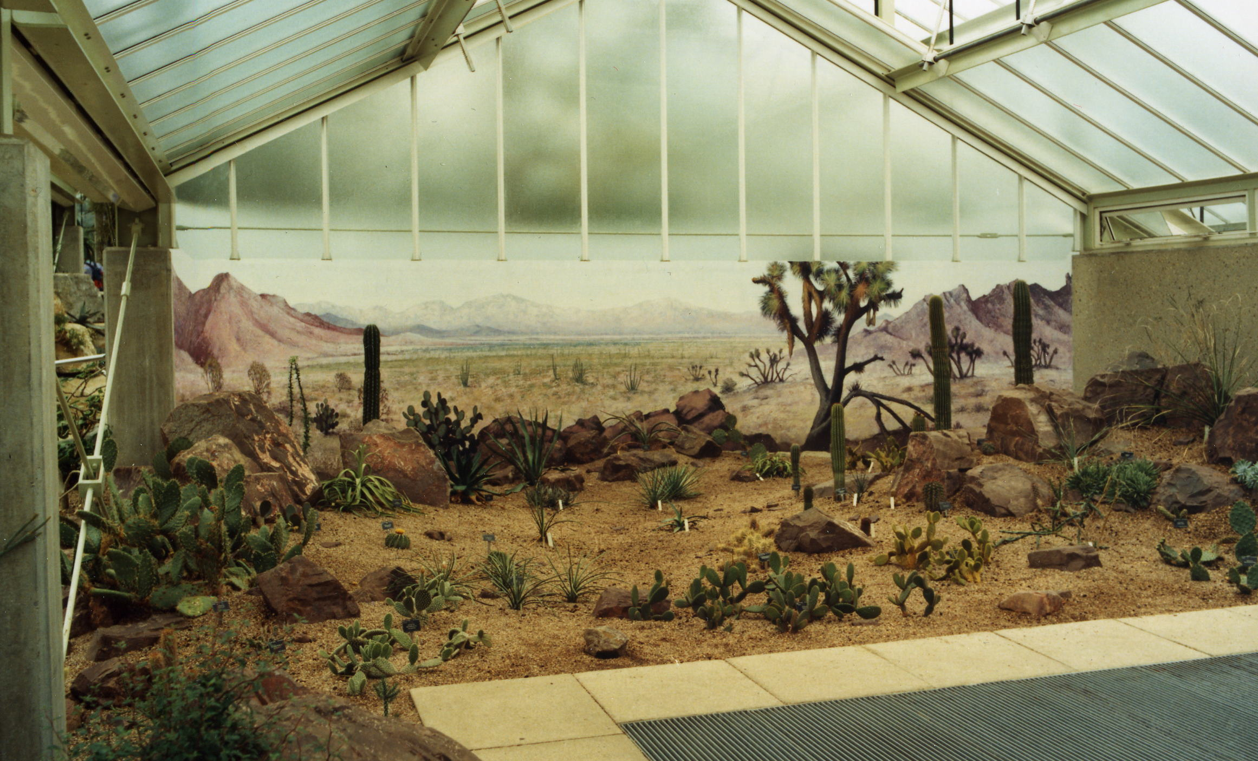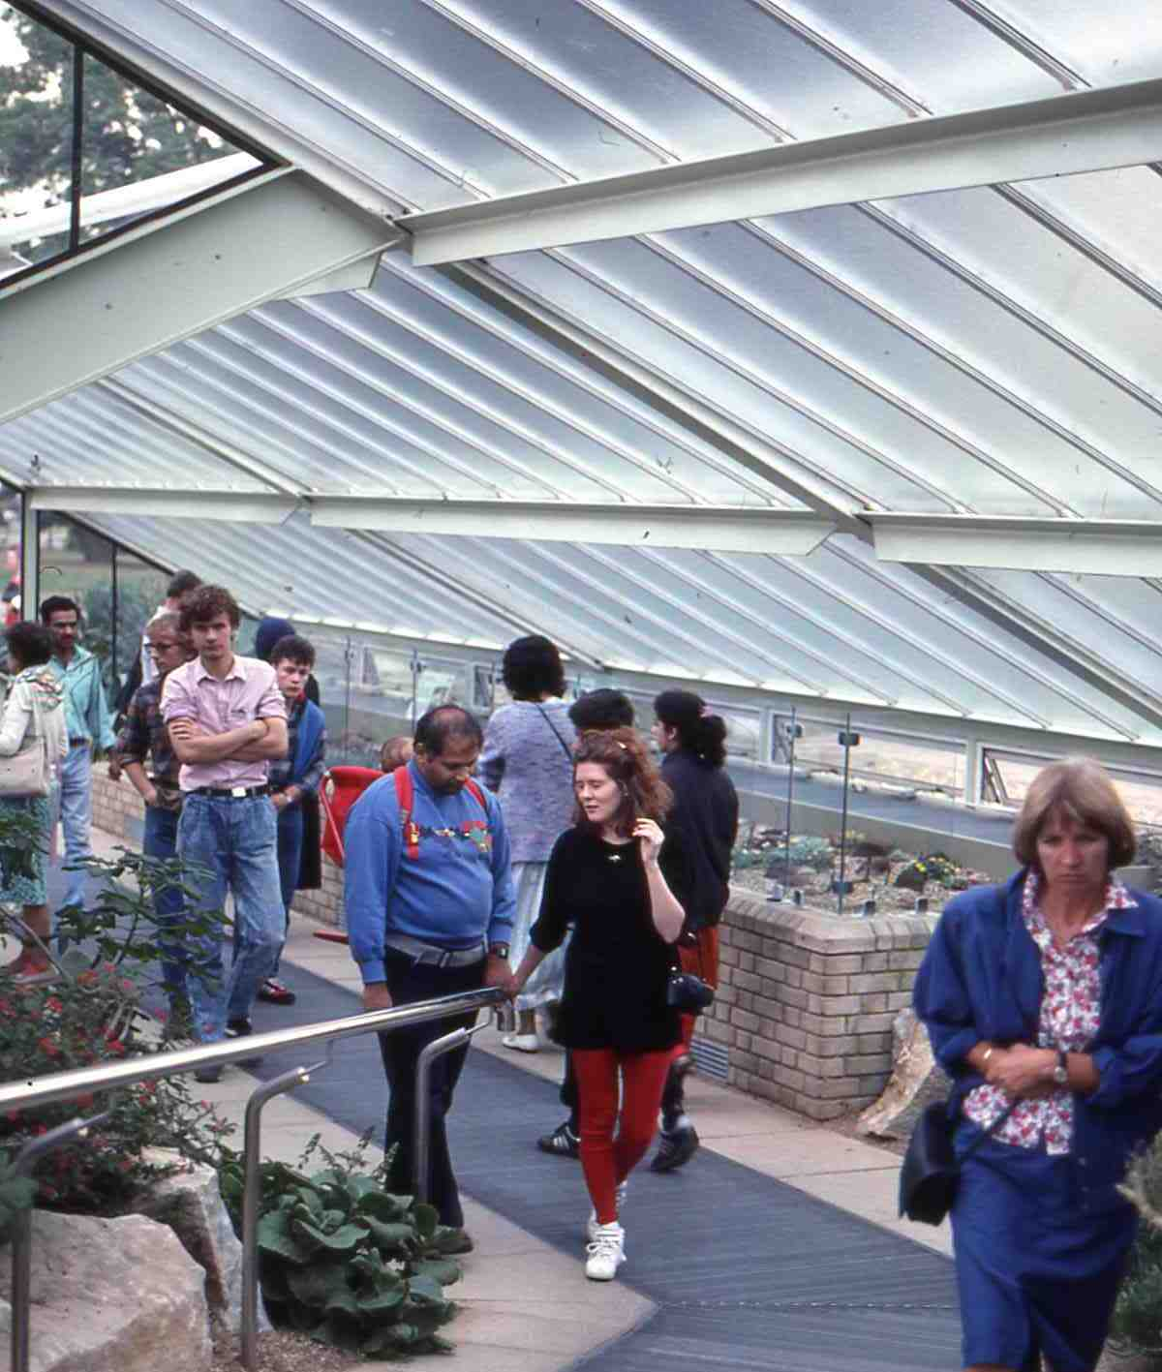
Mohave Desert Diorama feature Raised beds
The entry route through the south lobby, past the Diorama feature and the first line of raised, succulent beds is arranged as an expanding series of small introductory spaces before reaching the larger spaces beyond. A good location for discussing the internal appearance of the conservatory is the viewing point at the top of the ramp overlooking the main dry-tropics display

10. Cast glass and plant display

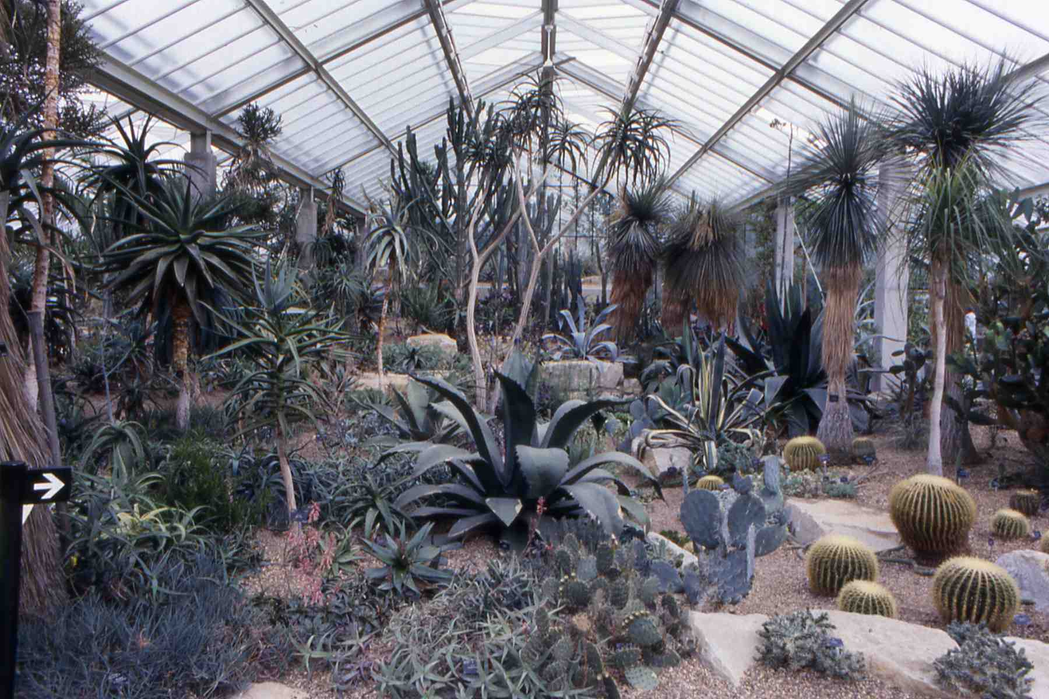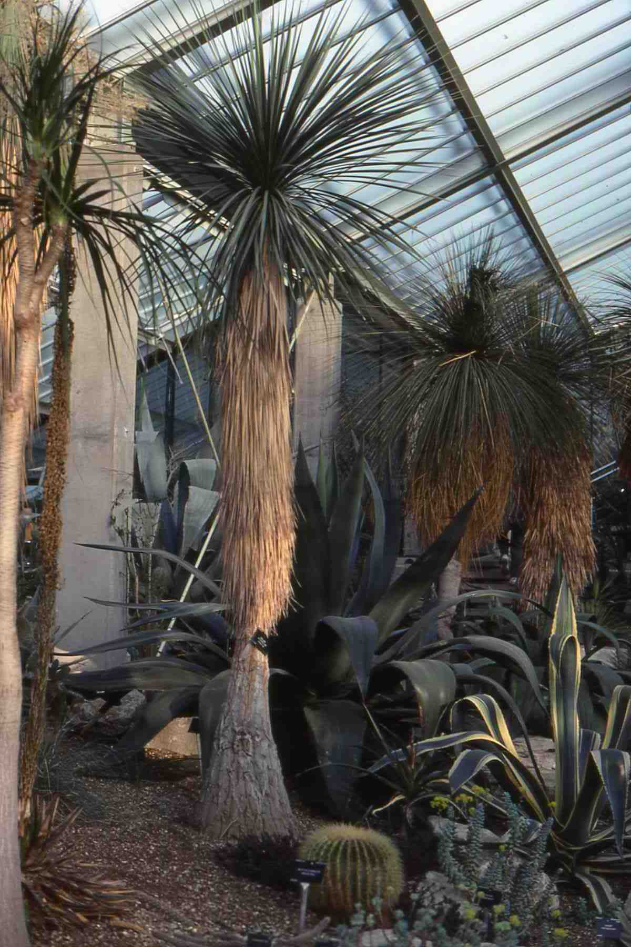
Main dry-tropics display Spiky forms against cast glass

The display of succulents is one of the more challenging aspects of conservatory design. Succulents have relatively sparse and thin foliage which makes them difficult to display in a conventional conservatory. Here, looking up at the glazed roof, plants with thin, spiky forms can be seen clearly silhouetted. The cast glass effectively hides all of the sky and approximately 70% of the roof structure, thus providing a relatively calm and non-distracting background for viewing all plants, with the added benefit that it distributes light more evenly and also reduces the need to clean the glass so frequently. Looking back at the roof above the ramp, visitors can assess the value of cast glass in comparison with clear glass, by comparing foliage seen against sky, clouds and distant trees

11. Clear glass and internal structure

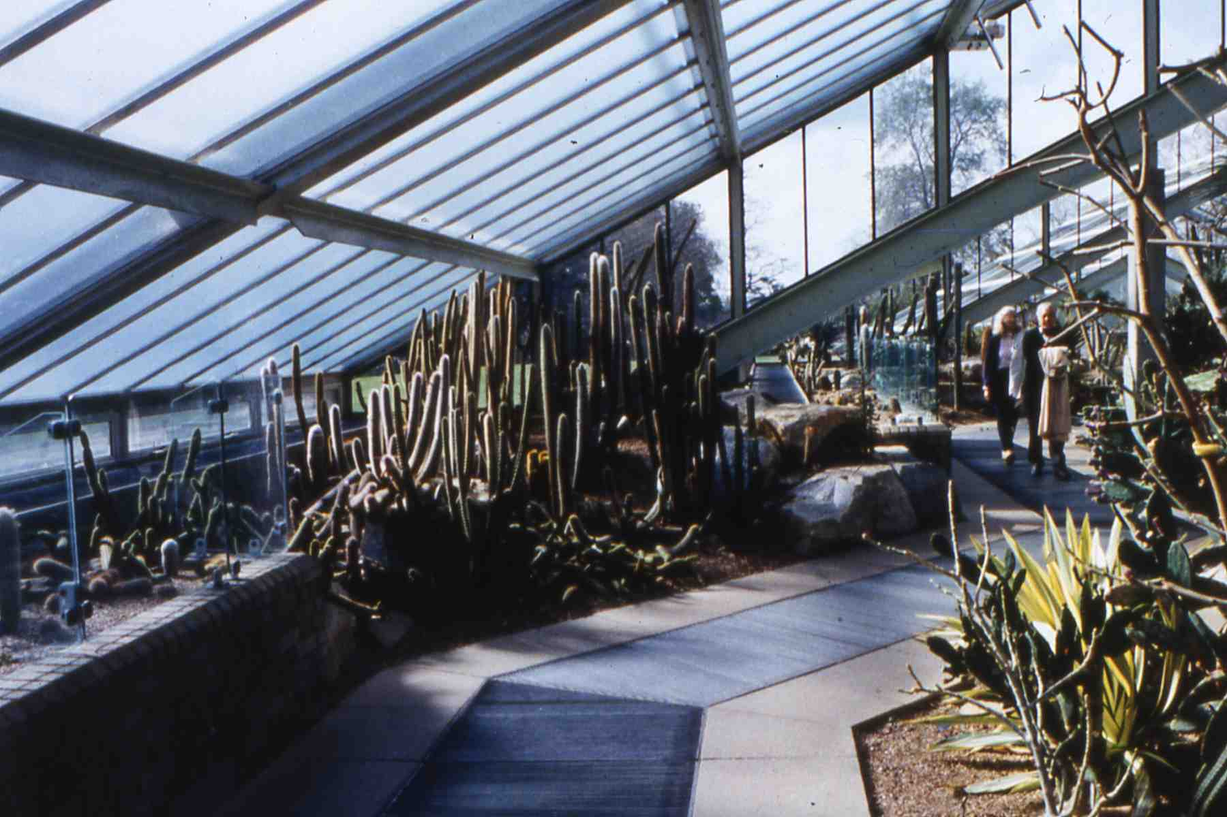
Looking South in the dry-tropics zone

The purpose of the relatively small areas of clear glass, i.e. in all vertical glazing, is to provide a visual link to the outside and to prevent any feeling of claustrophobia. Also, the approximately 30% of roof structure seen internally gives a re-assuring display of the structural system as well as providing a minimum structural support for fixing internal partitions

12. Visitor circulation

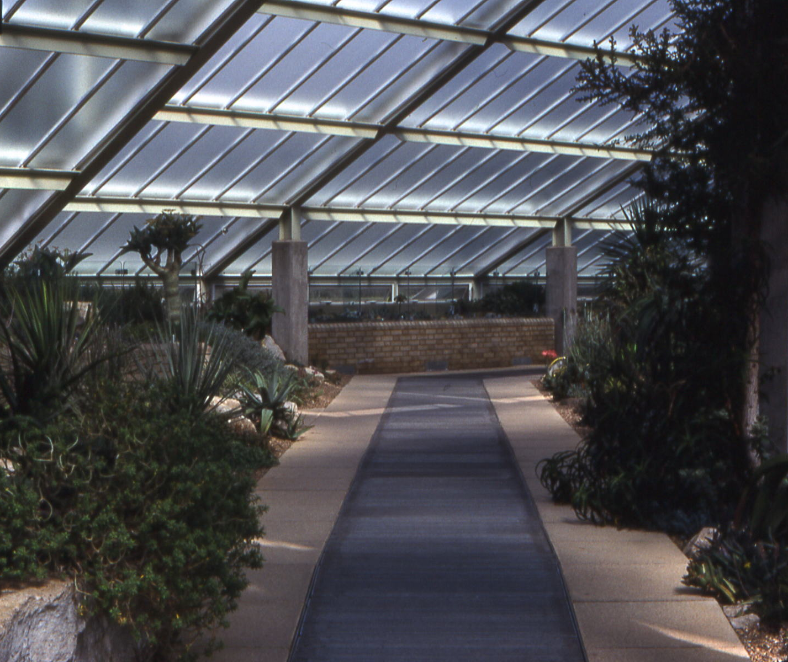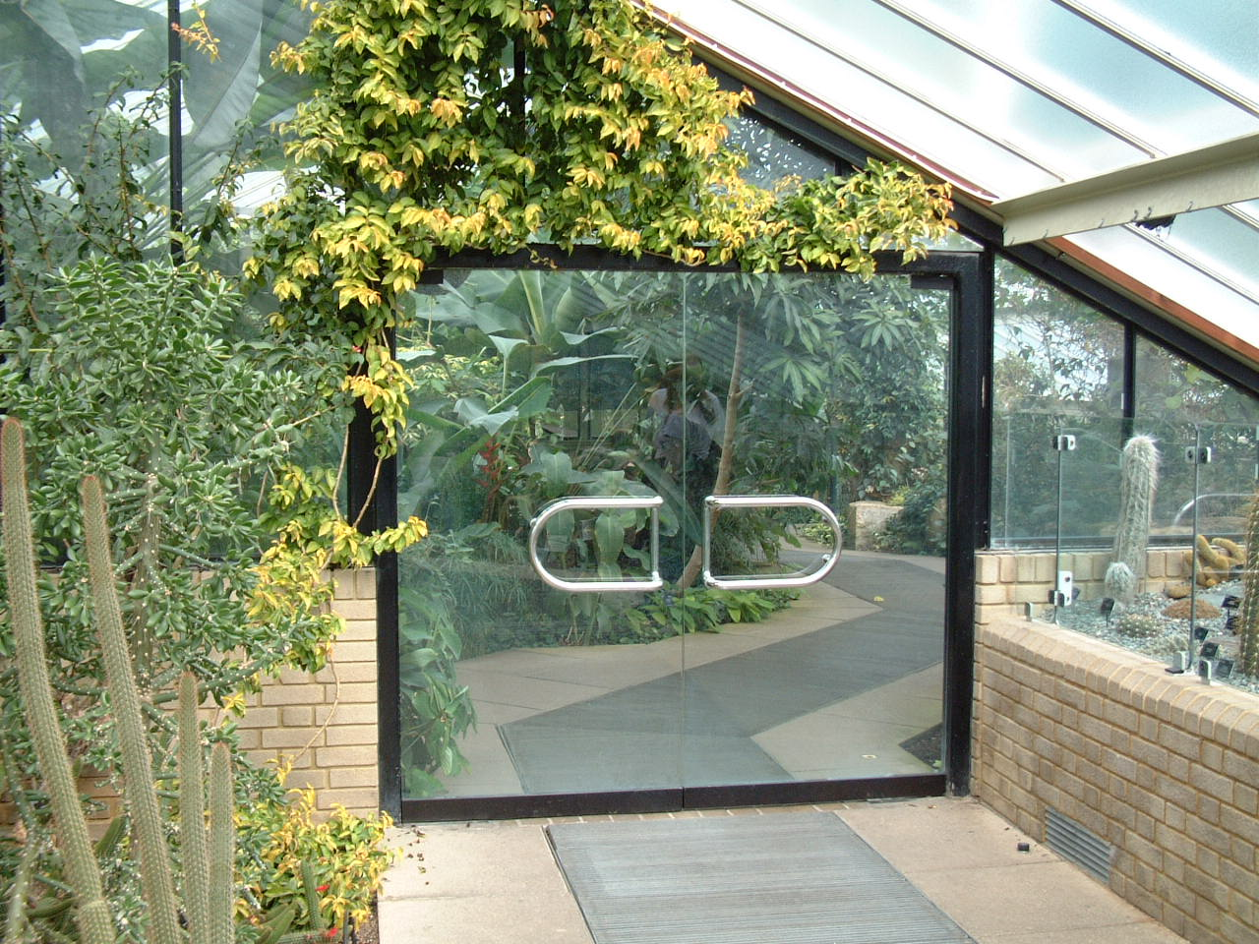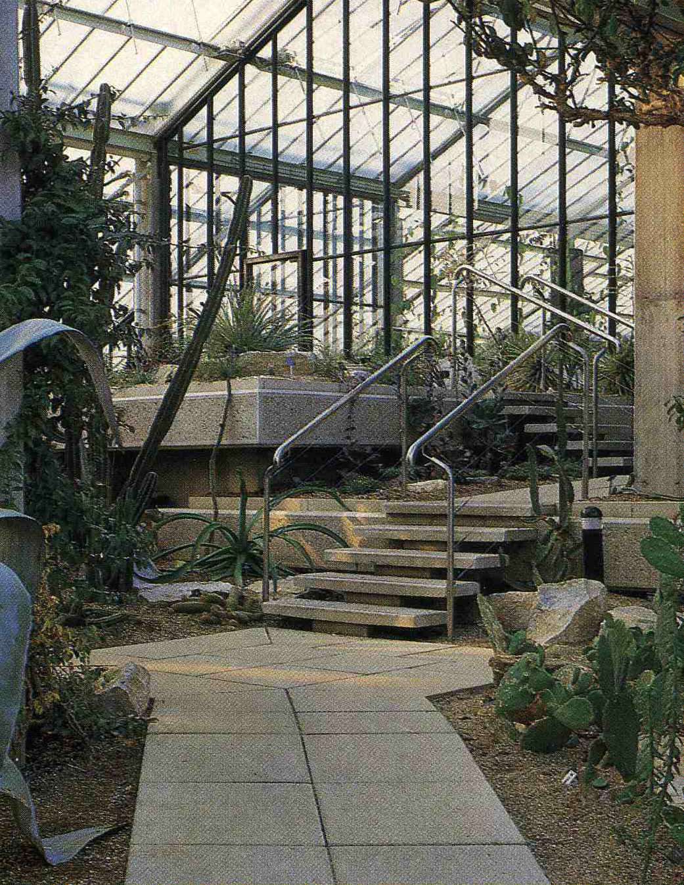
Perimeter path on West side Perimeter path on East side Secondary path

From the top of the ramp, a choice of main paths provides easy access through the main spaces for all visitors and staff. Access to the various levels in all zones is by narrower paths that have either steps or a stepped ramp for wheeled traffic. A tour of the conservatory to finish at the North entrance offers a wide choice of routes, according a visitor’s interest and the time available

13. Perimeter raised beds

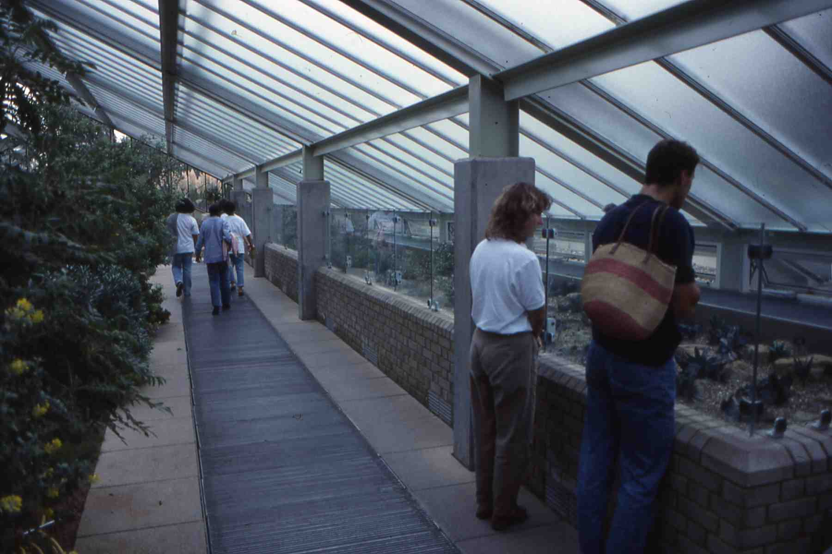
An improved design for exhibiting smaller plants

The perimeter raised beds for smaller plants replace the previous traditional benches. In comparison, they provide improved plant growth and displays with less maintenance, heat and irrigation water. The design challenge is to permit visitors to give maximum attention to the smaller plant exhibits, allowing their gaze to be focussed comfortably downwards, with minimum visual intrusion from the structural elements above and behind the display. This is more daunting when anti-theft screens are also required. The key issues include the height and texture of the roof glazing and creating a low profile at the building perimeter in relation to the viewer

14. Larger plants and special displays

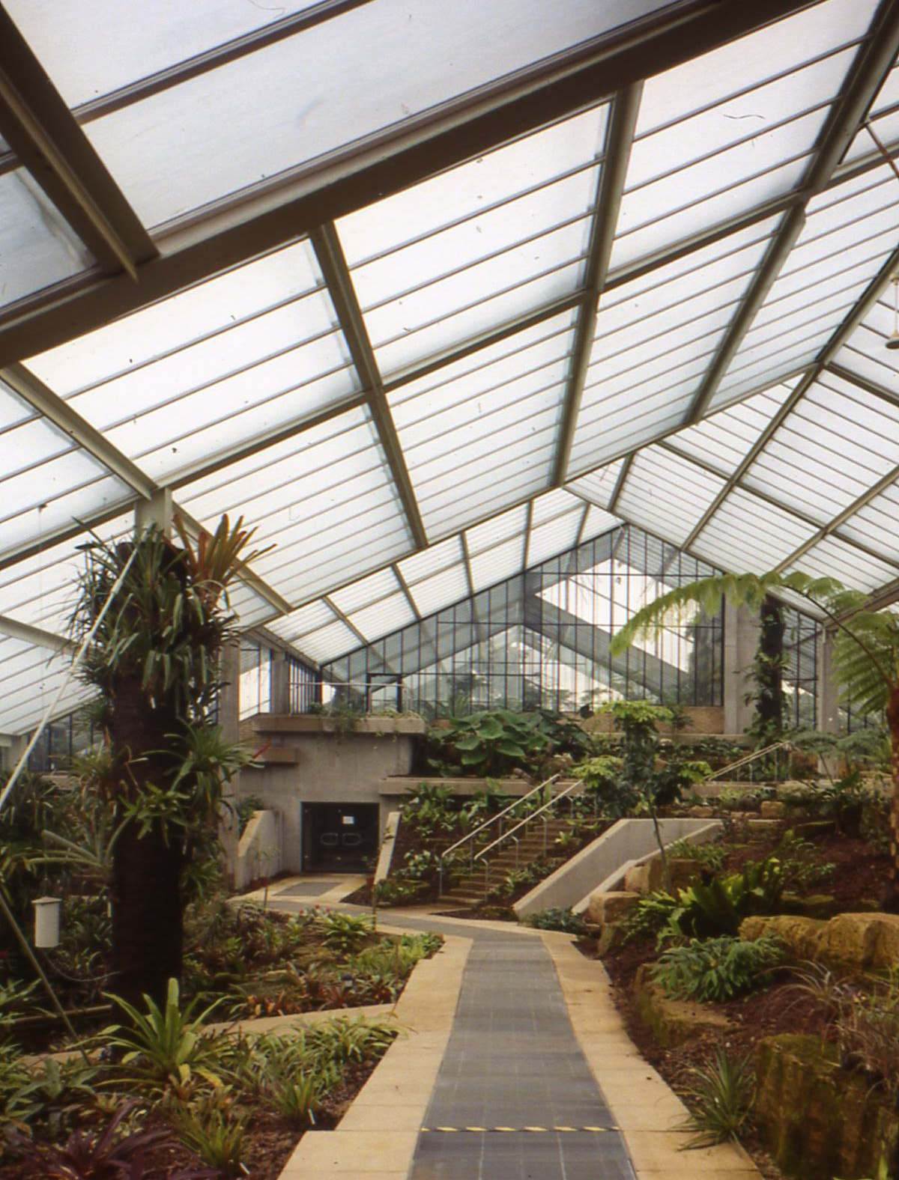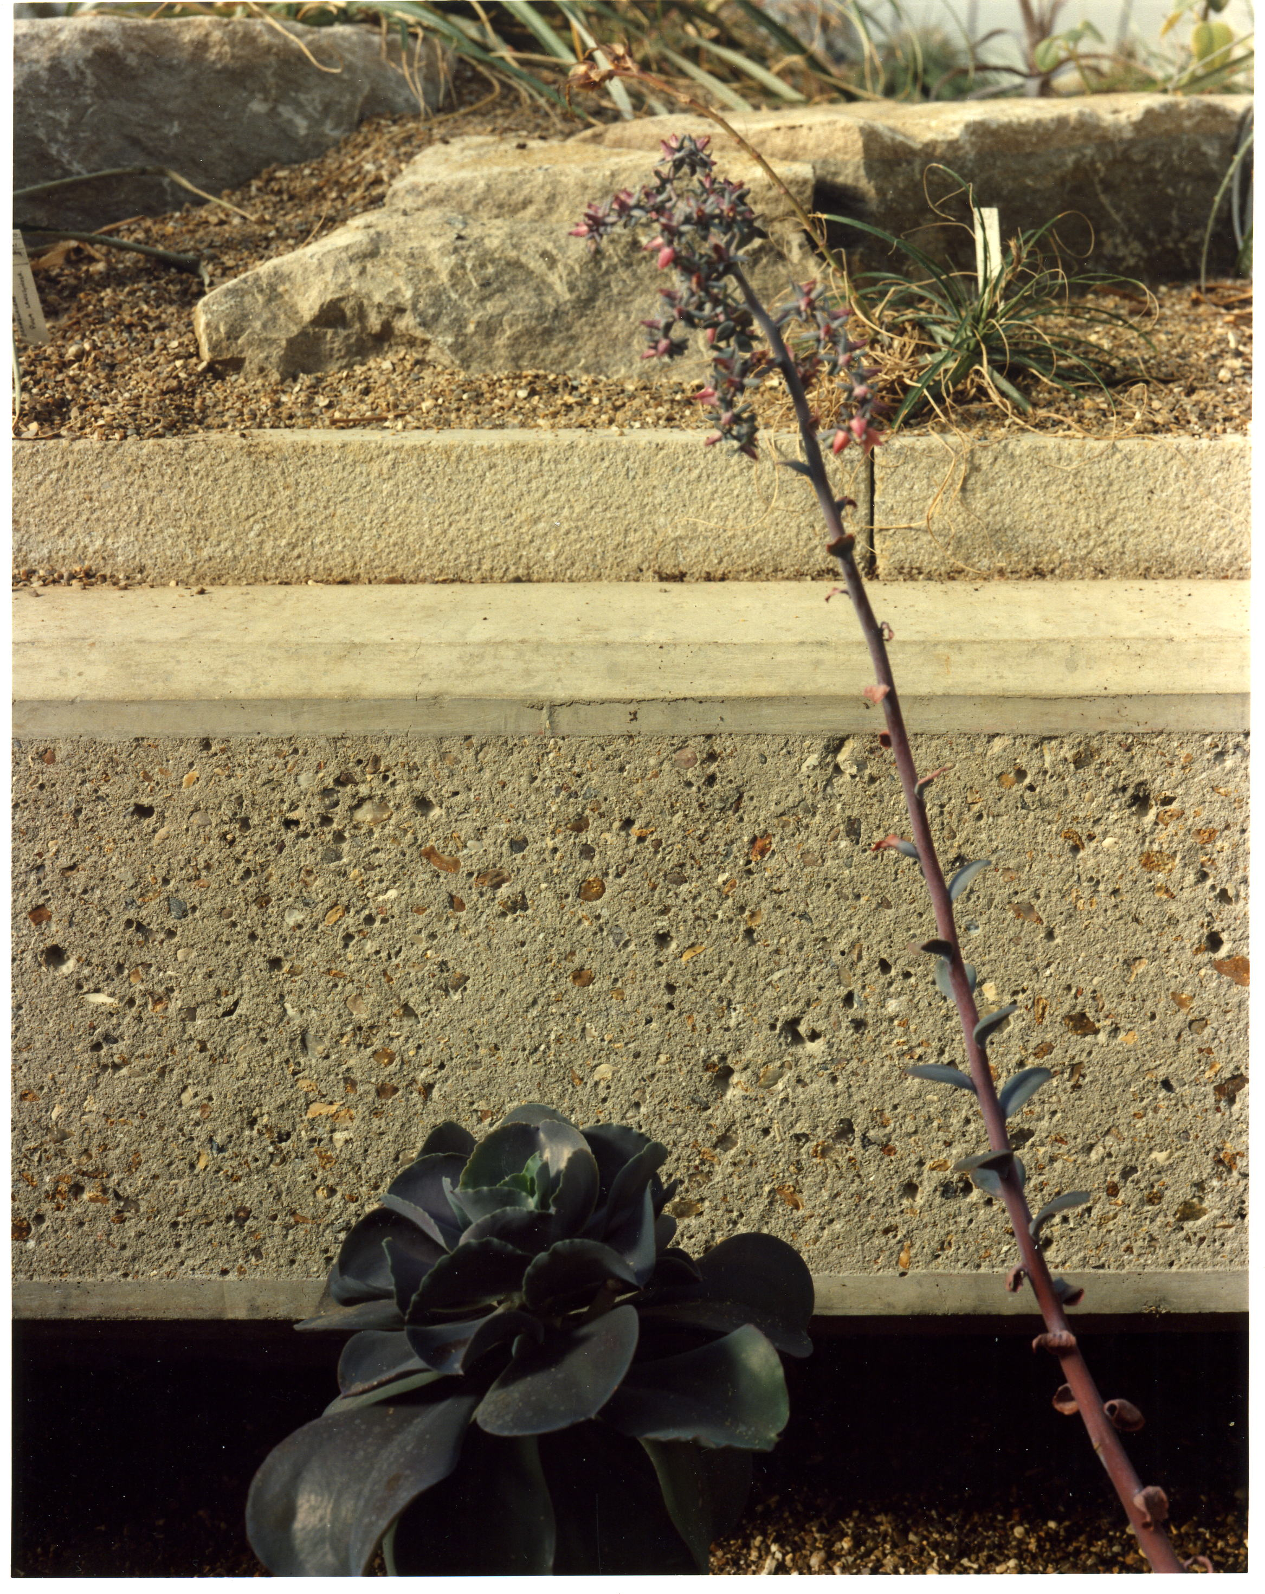
Larger, longer views Raised floor-deck carrying rocks and plants

Larger plant displays are located away from the perimeter to permit less restricted growth. They also provide a visitor with a larger, longer view to contrast with the more limited, focussed views along the perimeter. A visitor can proceed on the perimeter path selecting from a variety of contrasting views. Feeling relaxed and comfortable is part of the pleasurable experience. The special displays in various zones, including the main vistas in the two largest zones, rely on a services infra-structure to support regular changes of flora and fauna. These include displays where the concrete sub-structure is part of a major water feature or is a raised floor-deck carrying rocks and plants

15. Use of levels

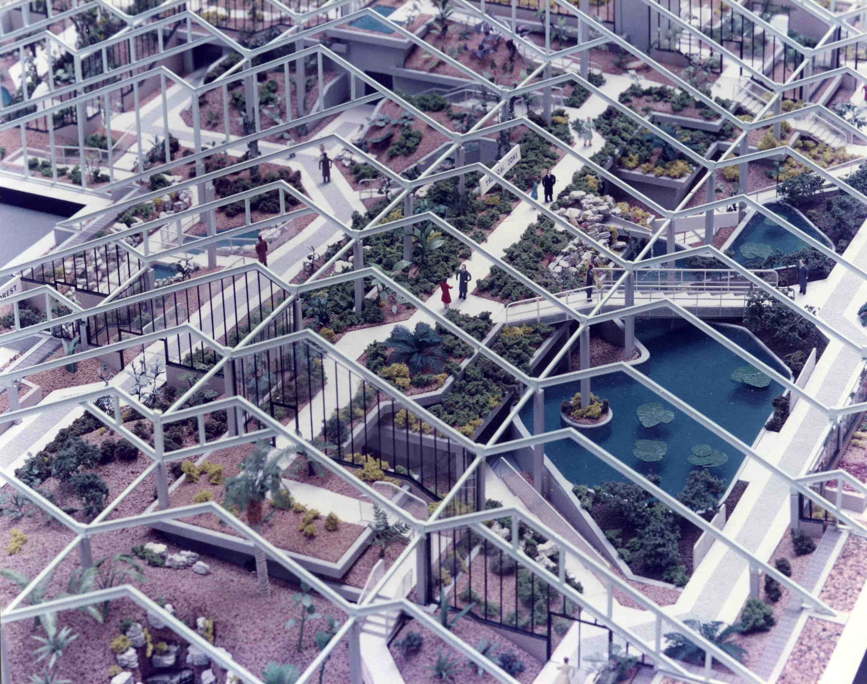
Pre-construction model showing the various levels over the central services zone

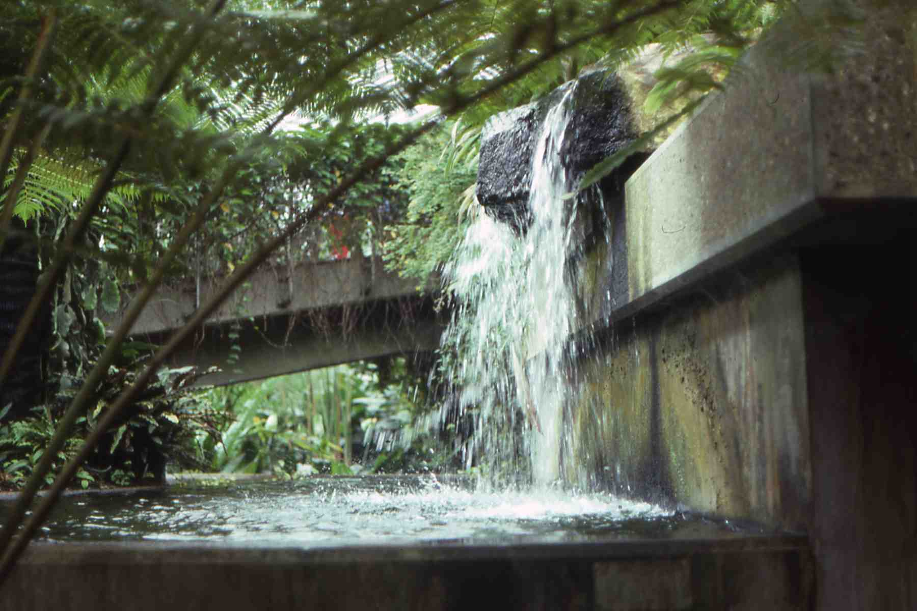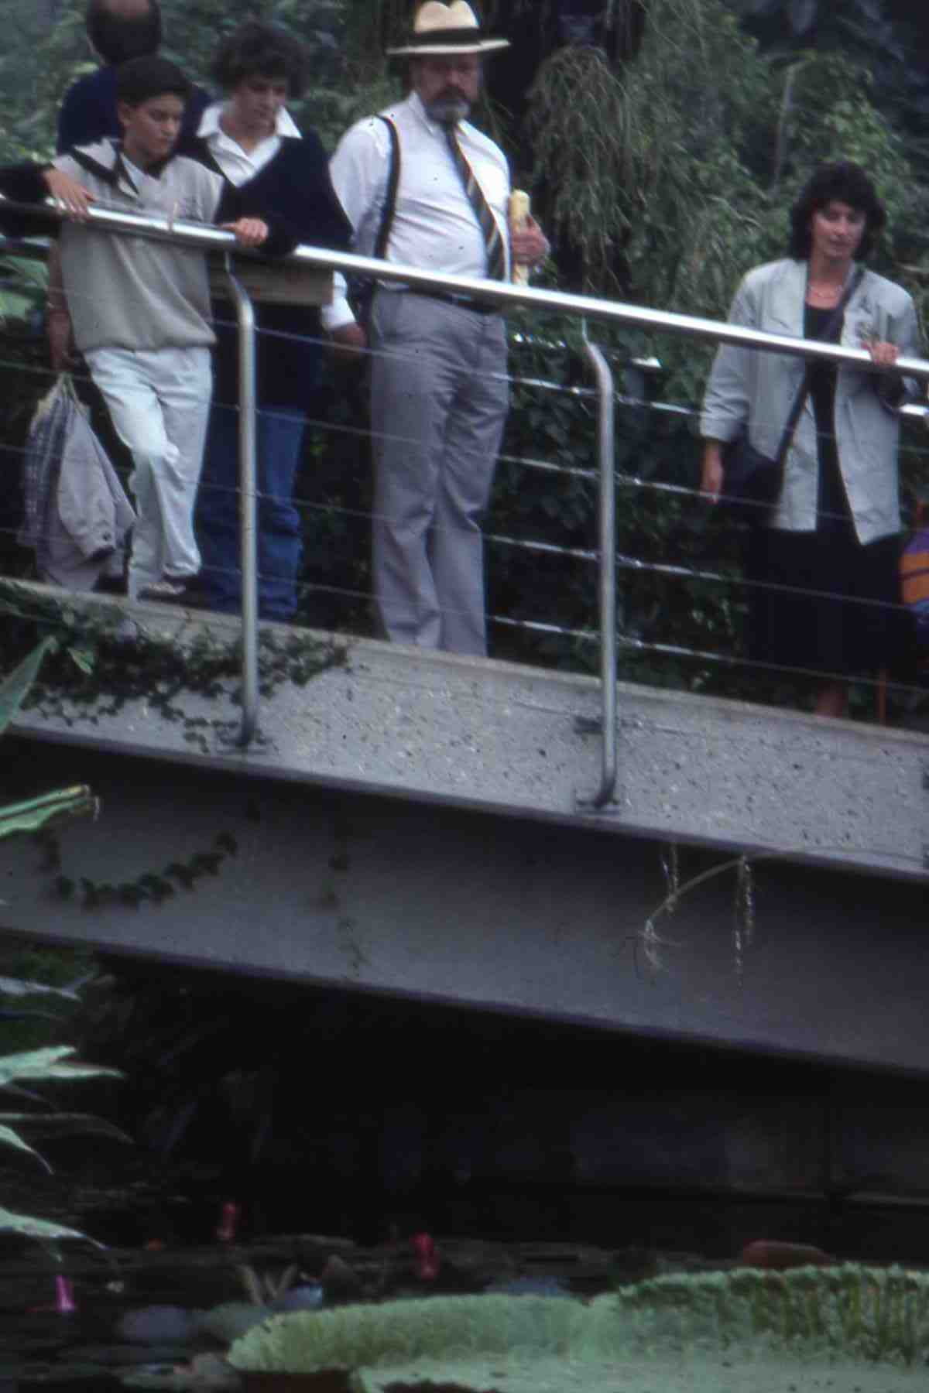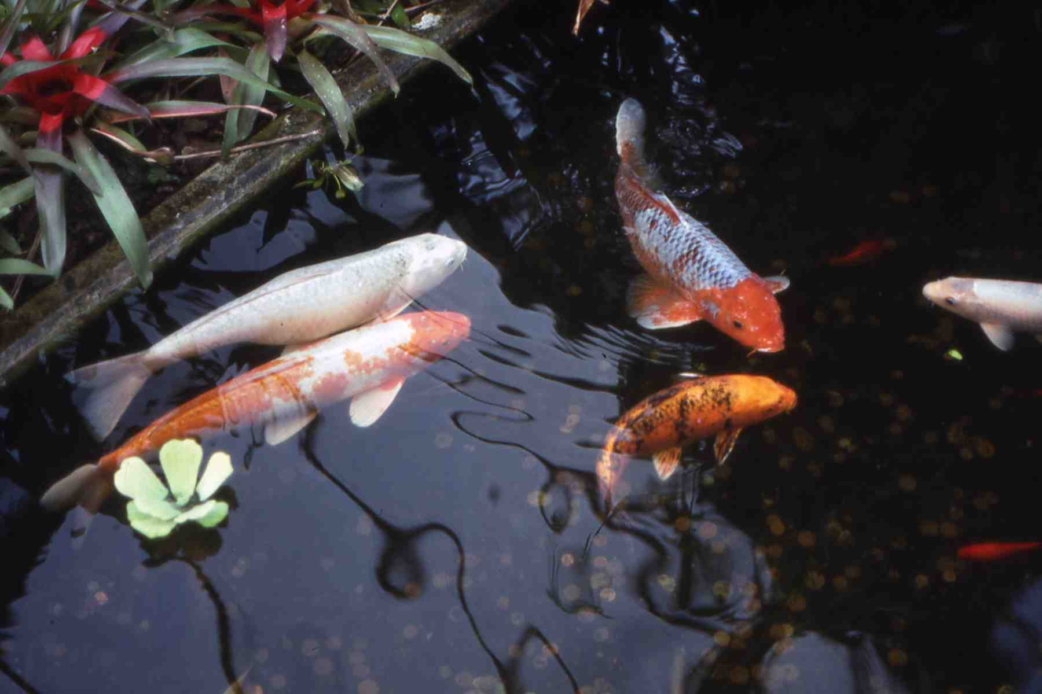
View up View down Close view

The ramps and stairs leading off main paths are used to generate new, changing views and opportunities for displaying plants, which now can be viewed from above and below. A good example in the wet-tropics area is the view down from the bridge over the main pool and up from the semi-basement aquarium area

16. Design for maintenance

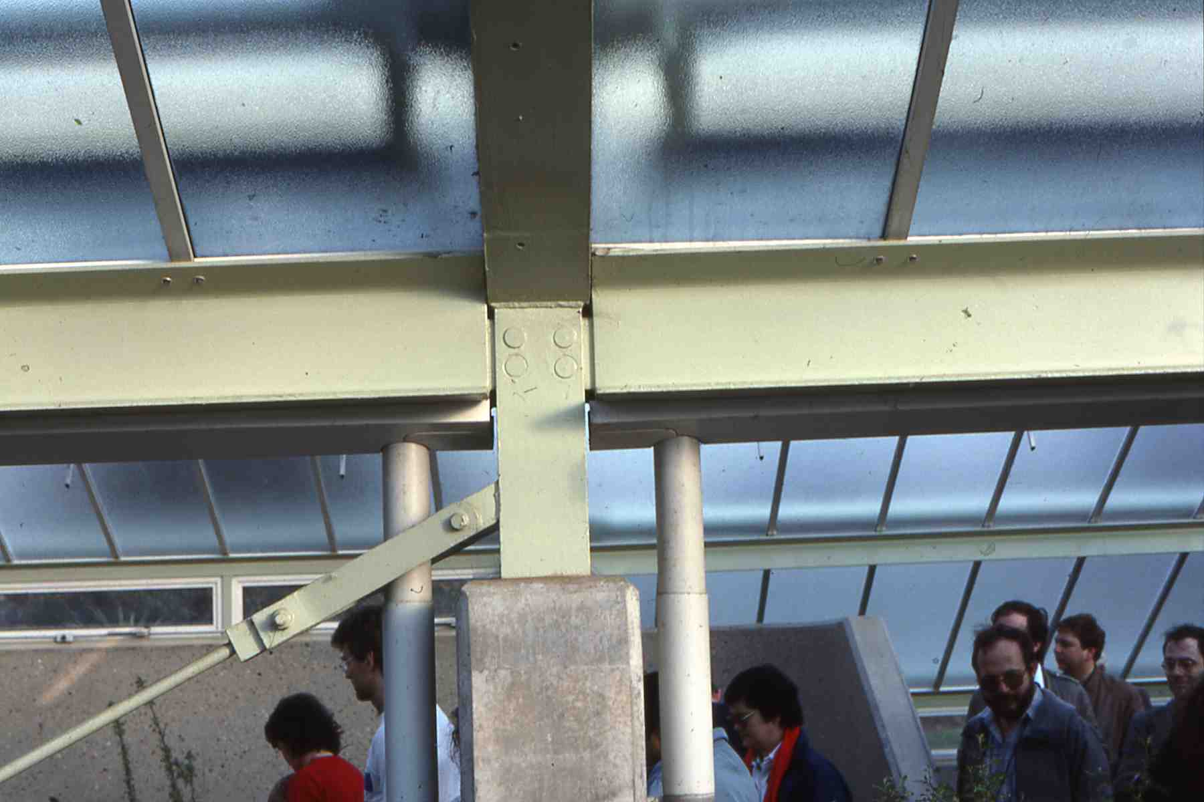
Steel valley-purlin junction

The steel superstructure requires protection from a constantly-humid internal environment that is potentially more corrosive than an external environment. The paint system chosen is chlorinated-rubber on flame-sprayed aluminium on steel that has been blast-cleaned. The main advantage of chlorinated rubber is that it can be re-applied easily in humid conditions. The structural elements have no hollow sections and the detailed design permits all surfaces to be accessible for inspection and maintenance, including at the valleys where the polypropylene gutters and down-pipes are re-mountable. In addition, the steel columns are given a concrete casing to support climbing plants and the steel roof-purlins and aluminium glazing bars can accommodate various fixing devices for carrying equipment

17. Environmental control

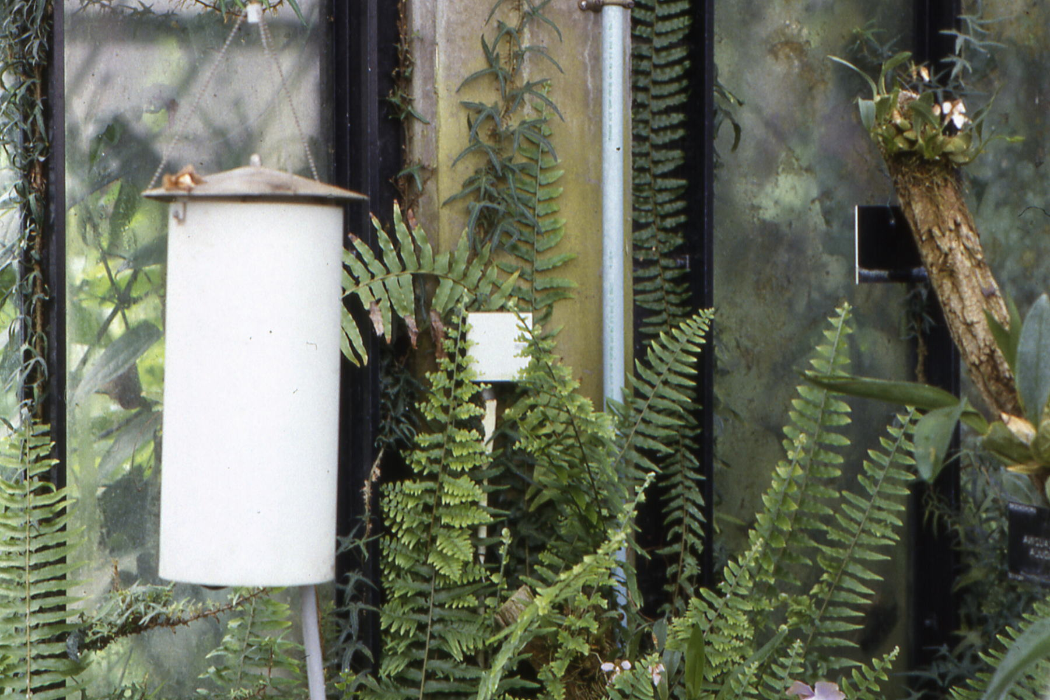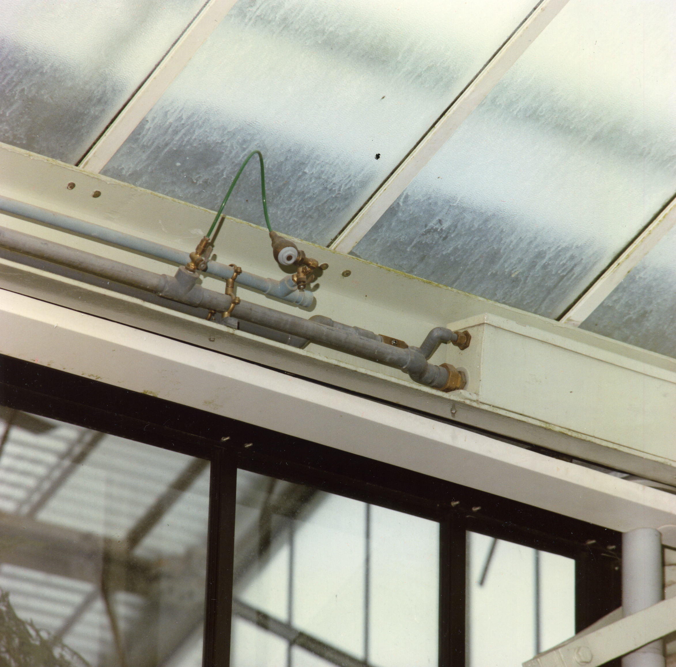
Suspended sensors Humidity control

In each zone the temperature and humidity sensors are visible, suspended in free air, in what look like Chinese lanterns. Additional sensors are located at high level to record the temperature differential caused by stratification. Energy is saved by using Punka fans to reduce stratification by circulating the air, driving the heat below leaf-level, where it is required. Humidity is controlled via water and compressed-air lines, fixed to the valley roof-purlins. A wind sensor mounted on the roof ensures that roof vents are closed in windy conditions. All sensors are linked to a micro-processor and controlled by a central computer. The critical systems operate automatically and include fail-safe solutions with alarms to alert staff on a 24 hour basis. In addition, there is manual operation of the perimeter side-vents, as an extra control to reduce internal temperatures on the hottest days. This enables staff to give extra comfort to both plants and visitors

18. Central services zone

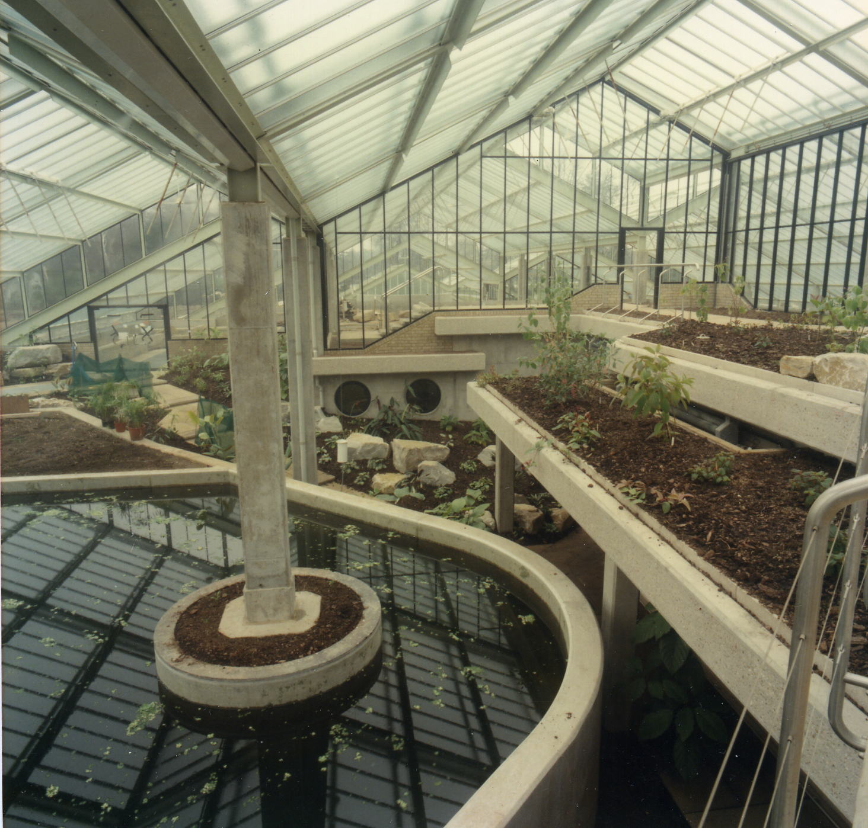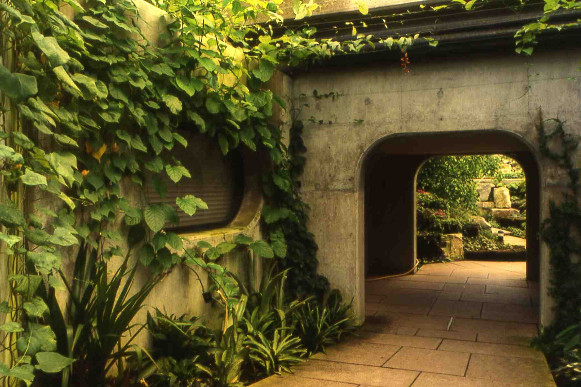
Southern part of central service zone Public access separating northern and southern parts

The central services zone in its semi-basement area is divided into two parts. The southern part contains staff rooms, preparation and maintenance areas, a server space and access to a large water storage tank in a sub-basement. The northern part has separate plant-rooms for air-handling, water treatment and boilers. Fresh air is drawn in via underground ducts from the adjacent, external service yard

19. Tropical Ferns

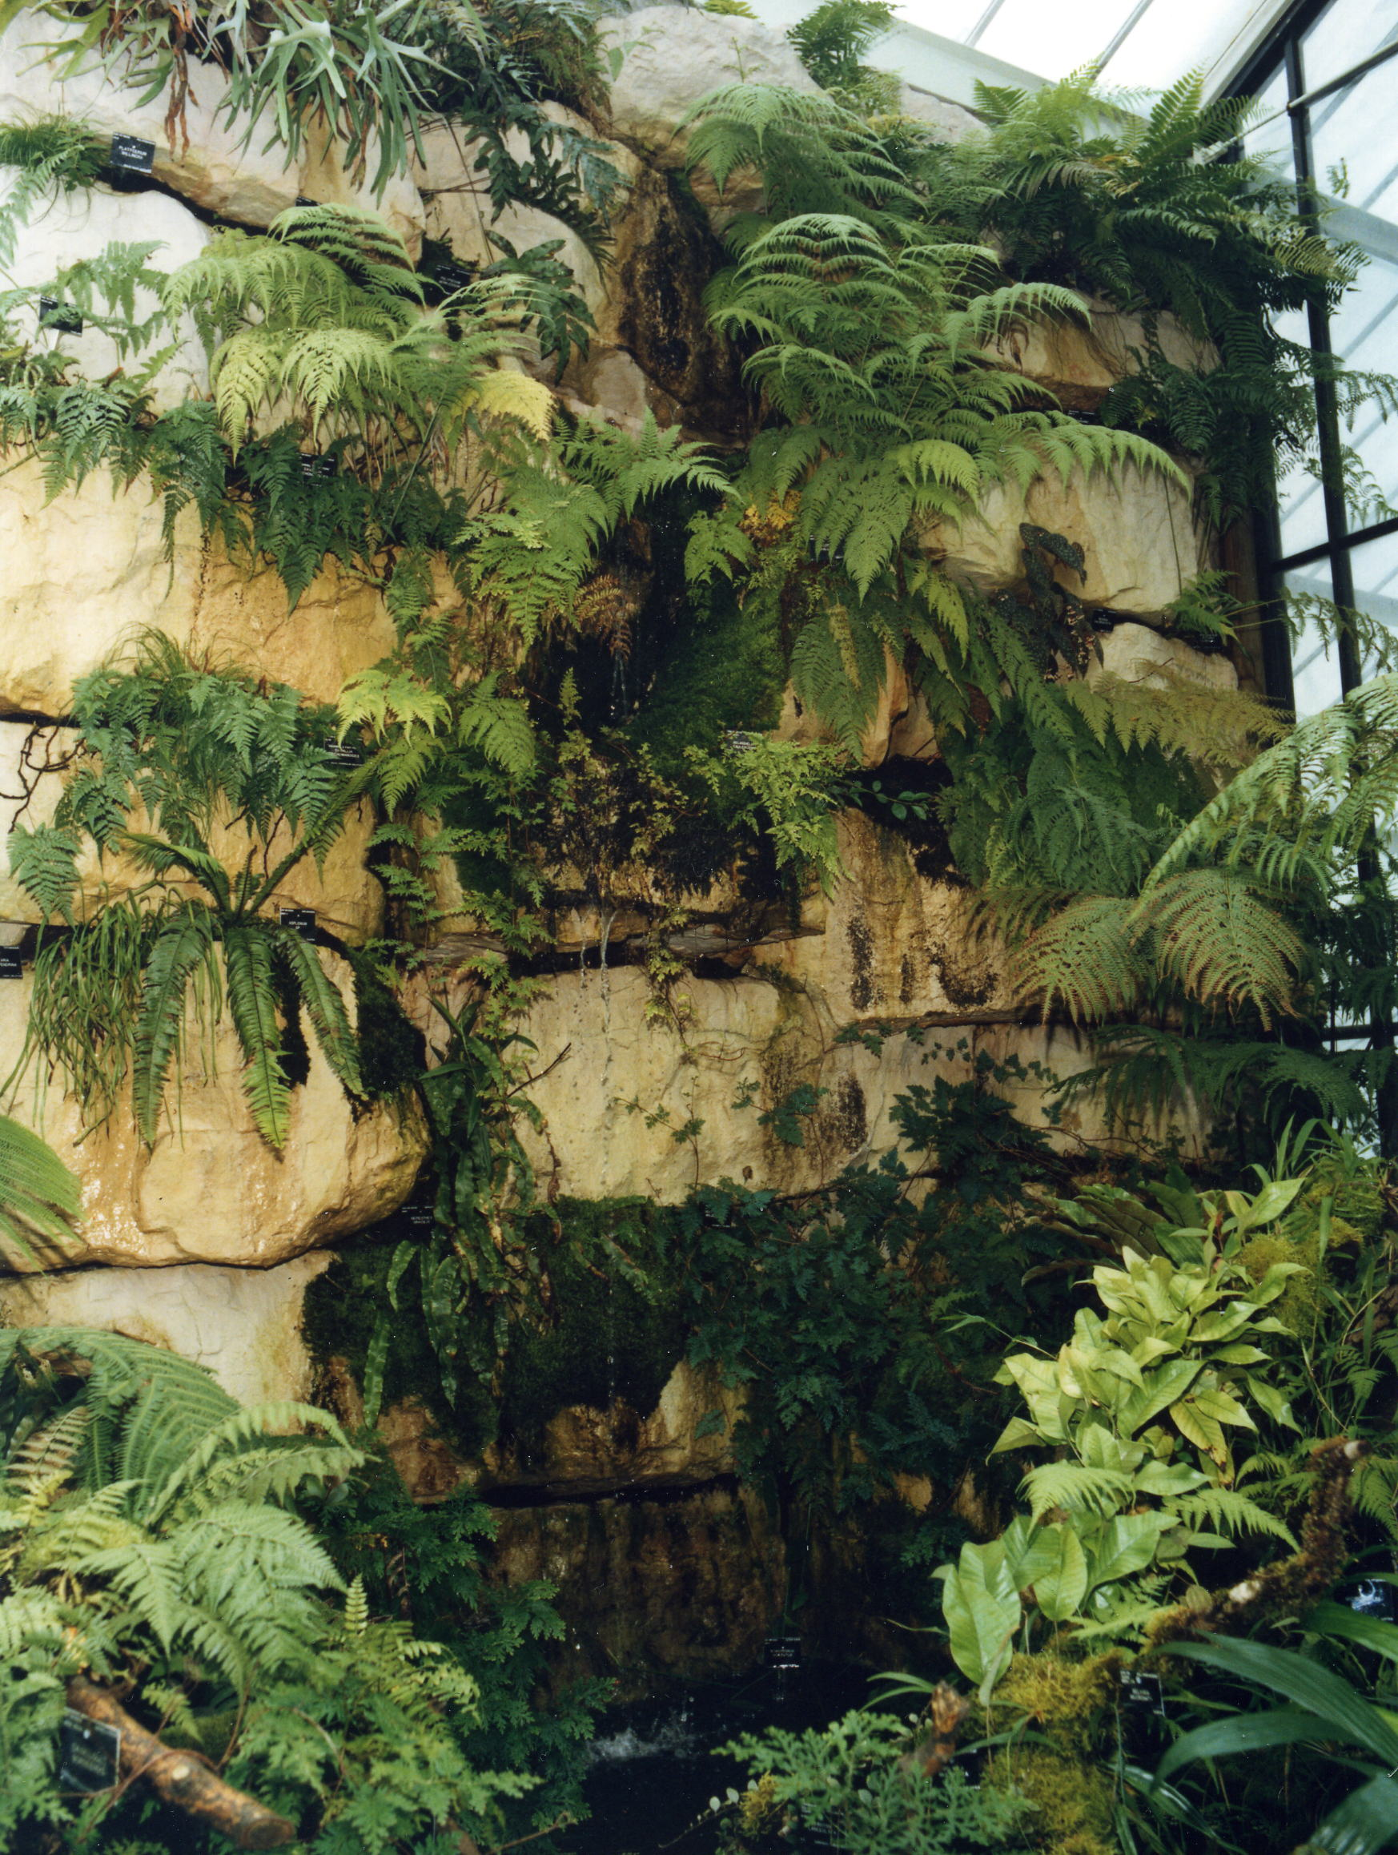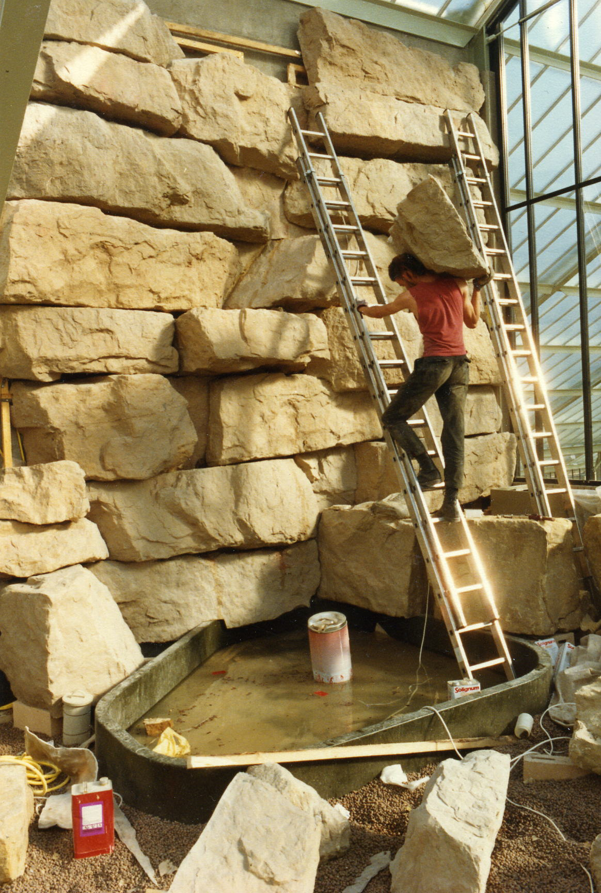
Boiler flue wall planted over Lightweight rocks

The tropical ferns zone is located in the highest, hottest and most humid space, at the northern end over the boiler room. It can be approached via the stepped ramp leading past the high-level viewing point in the wet-tropics zone. This viewing point also gives a close view of the humidity control system, with its water and compressed-air lines, located on the valley roof-purlins. In addition, the fixed internal shading can be seen on the south wall of the tropical ferns zone, supplementing its roof-shading. All roof shading within the tropical fern zone is external and operated automatically to respond to changing light levels. There is also a multiplicity of water-nozzles on the valley roof-purlins to testify to the high level of humidity. The wall containing the boiler flues is fully used for plant display purposes, clad in lightweight, artificial rocks to meet the structural loading constraints

20. Service Yard

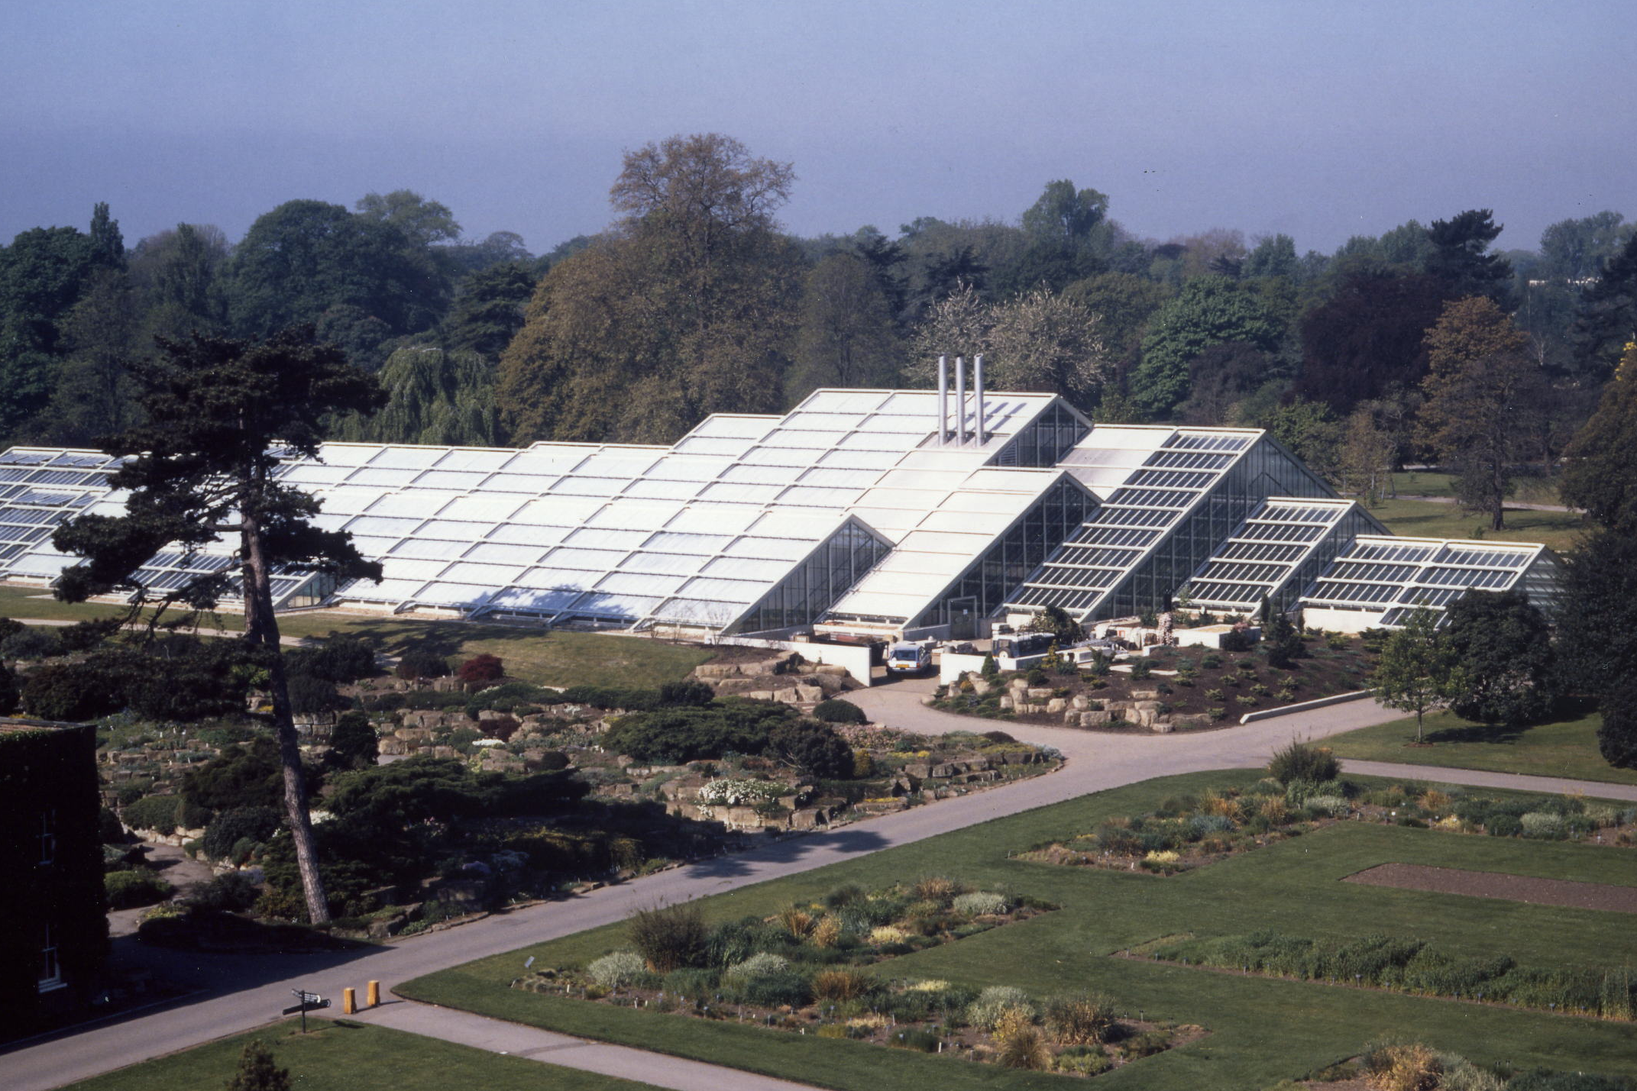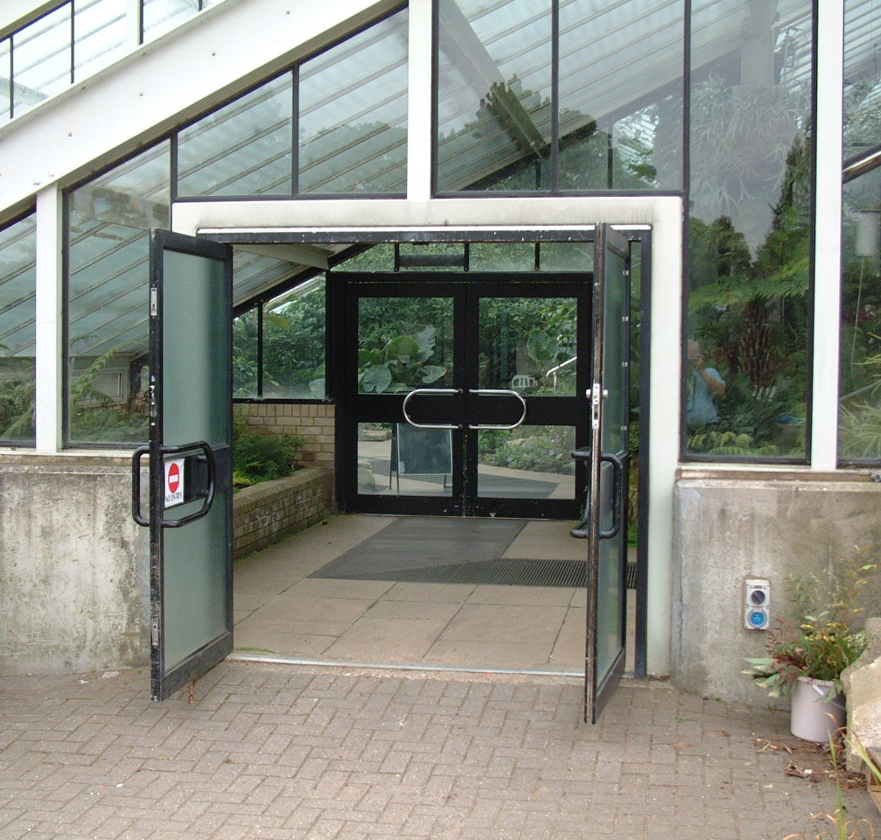
Unobtrusive service yard in the North-East corner of the site Access for a ‘cherry-picker’ if required

Traditionally, a conservatory’s service yard is located at its northern end, where the natural lighting is poorest. Here, it is moved to the North-East to make space for the main, North entrance. Also, because most service accommodation is located within the conservatory, it can be reduced in size and screened to be unobtrusive. It is a working area with larger equipment and with direct access into the conservatory

21. North entrance

Main entrance of Princess of Wales Conservatory

The layout concept at the North entrance has many of the features of the South entrance, but on a larger scale. The natural light conditions in winter can be surprisingly good, due to the amount of reflected light from the northern sky. The introductory space is used as a Winter Garden as well as for a variety of special displays. With its water features and clear glass walls, giving visitors a comfortable transition between inside and out, it is also a suitable point to complete the tour

Gordon Wilson
June 2005

